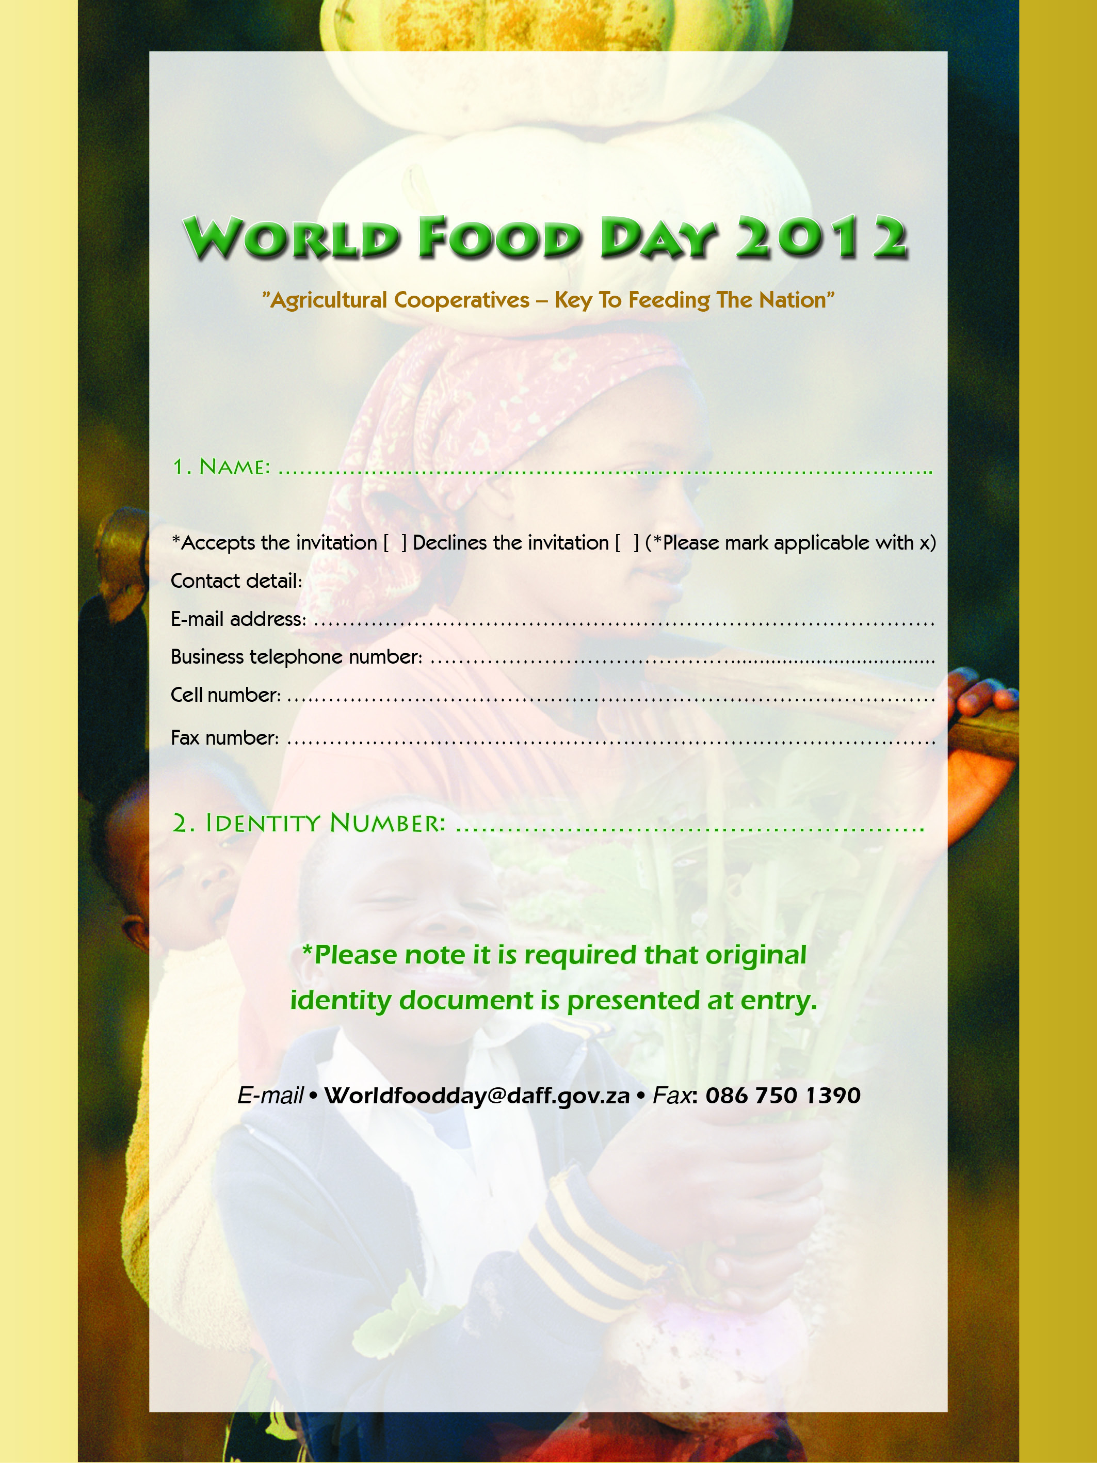
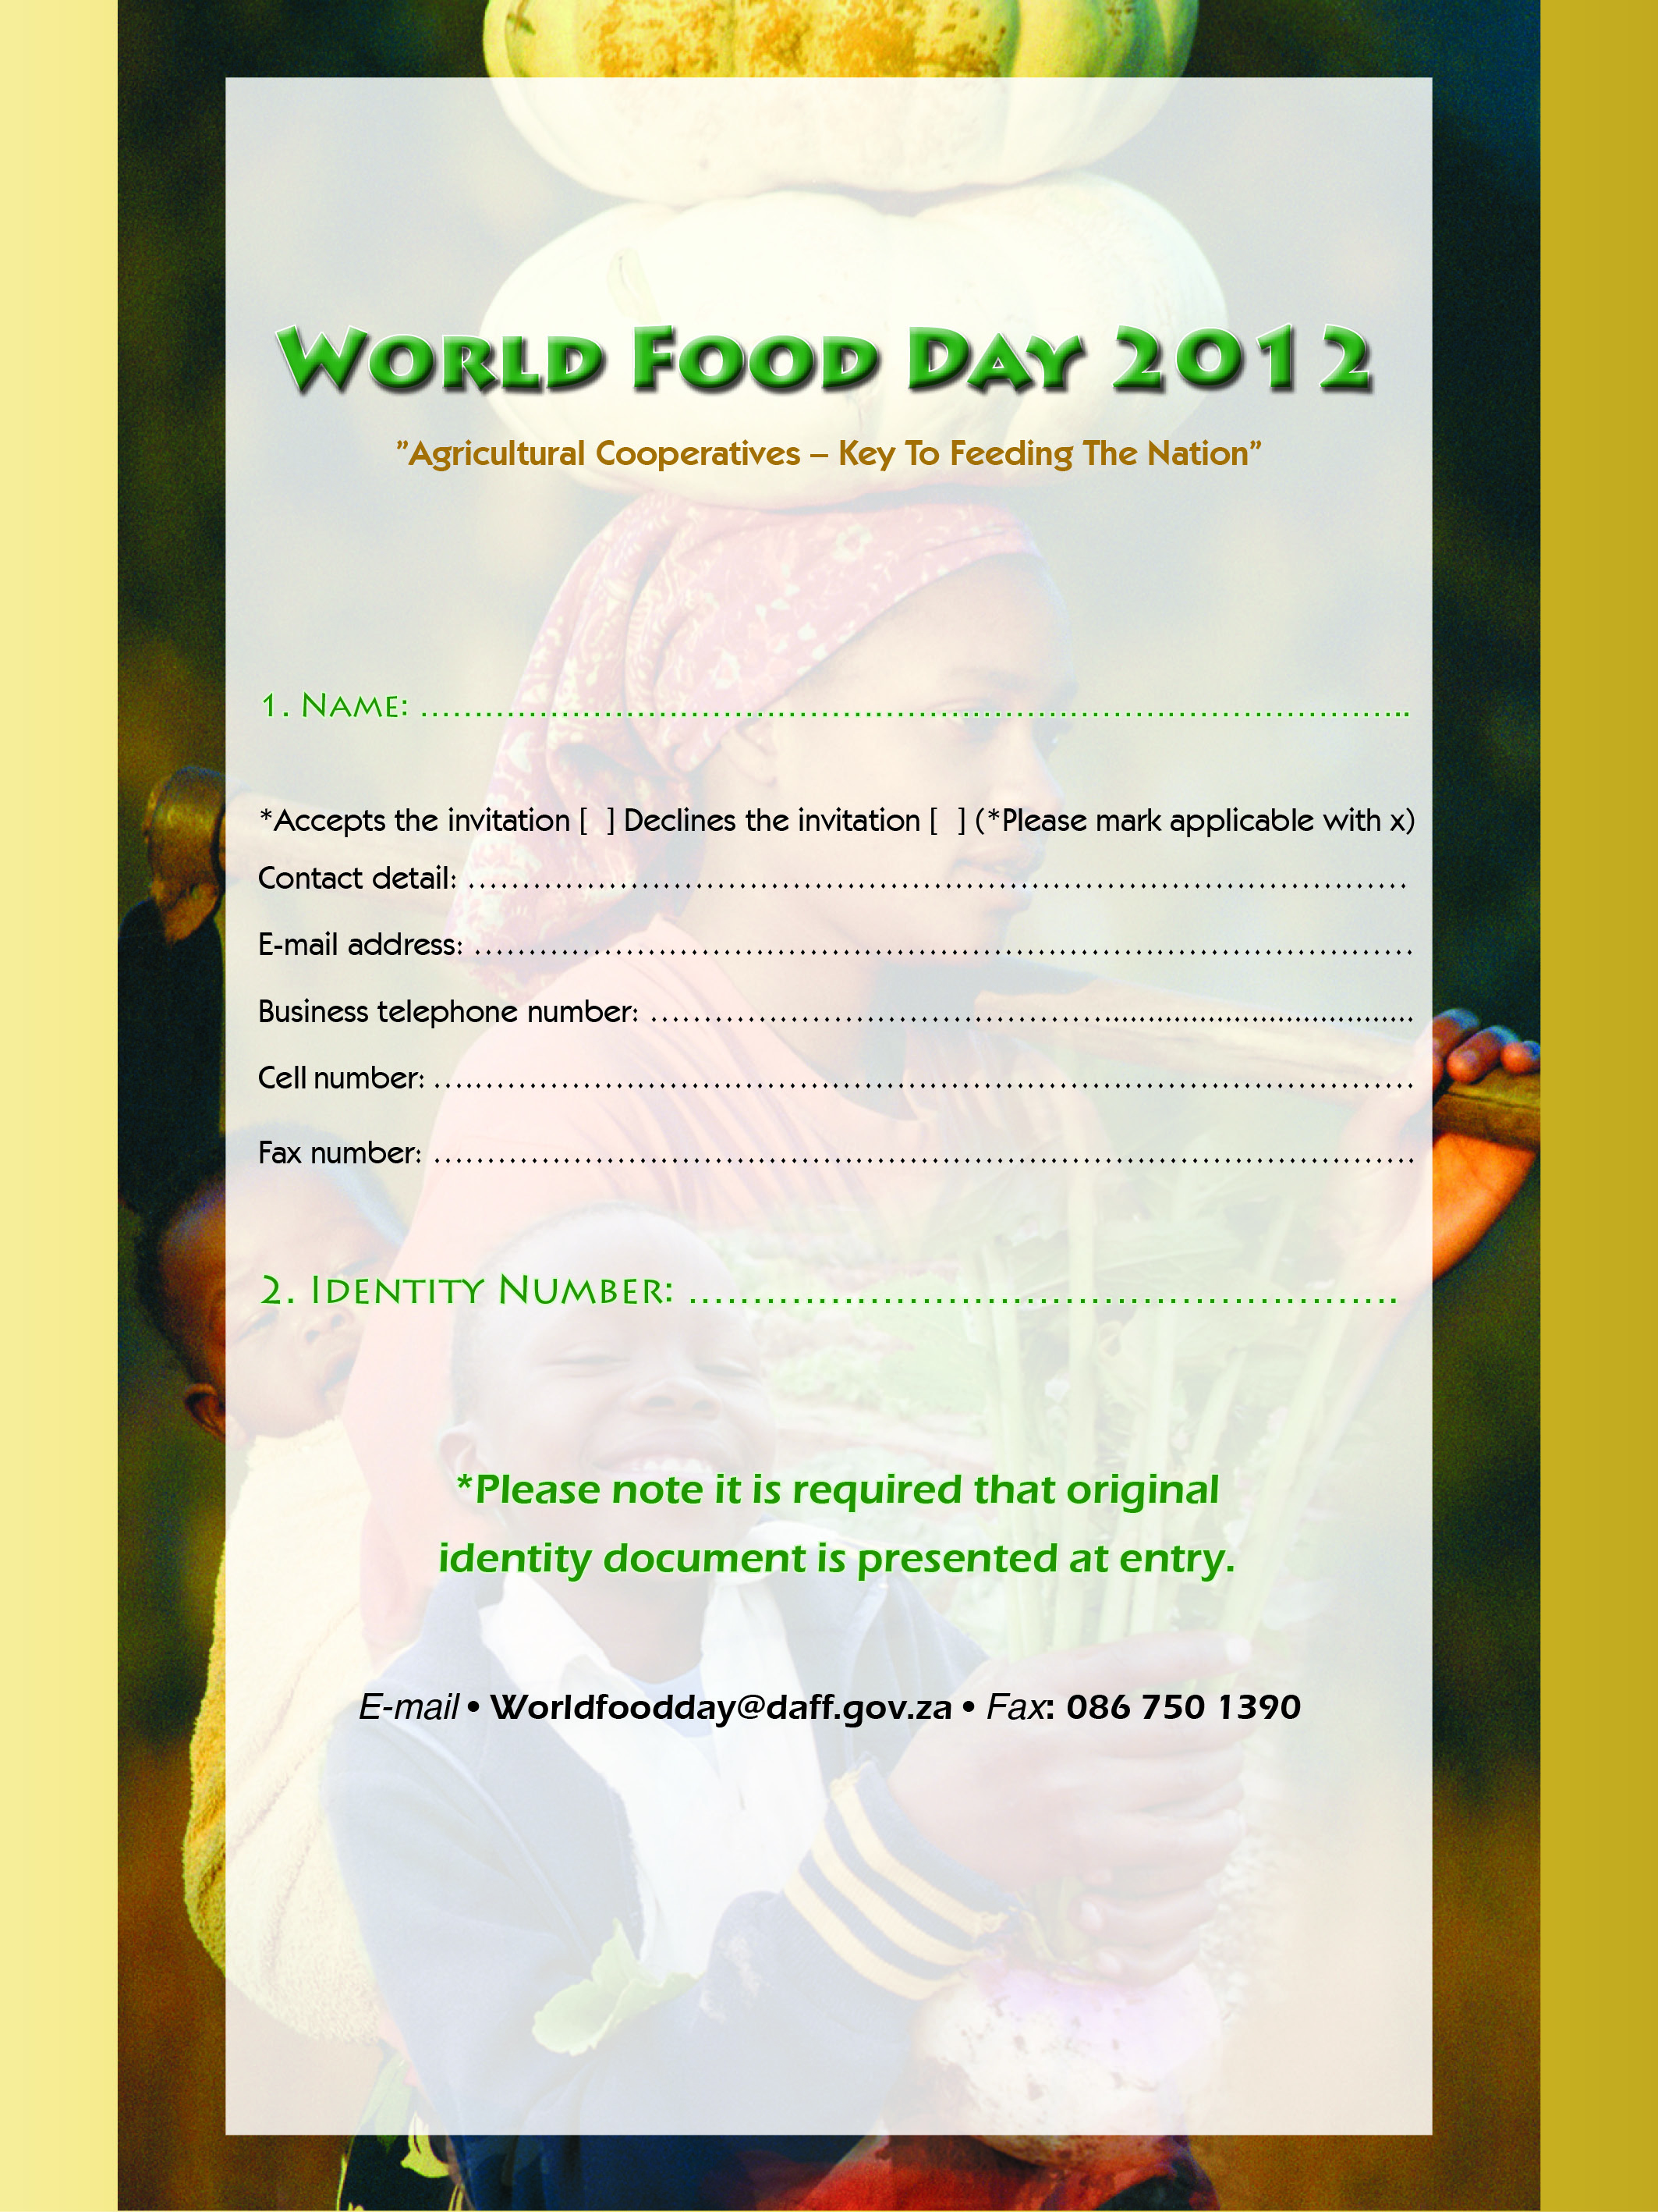

KJKJHKJHKJHKJH

KJGJHGJHGJH

KJHGKJHJKHKJHKJH
HJHGJHGJHGJHGJH

JHGJHGJHGHGK

KHKJHKJHGKJG

GJHGJHGJHGJHGKJG

