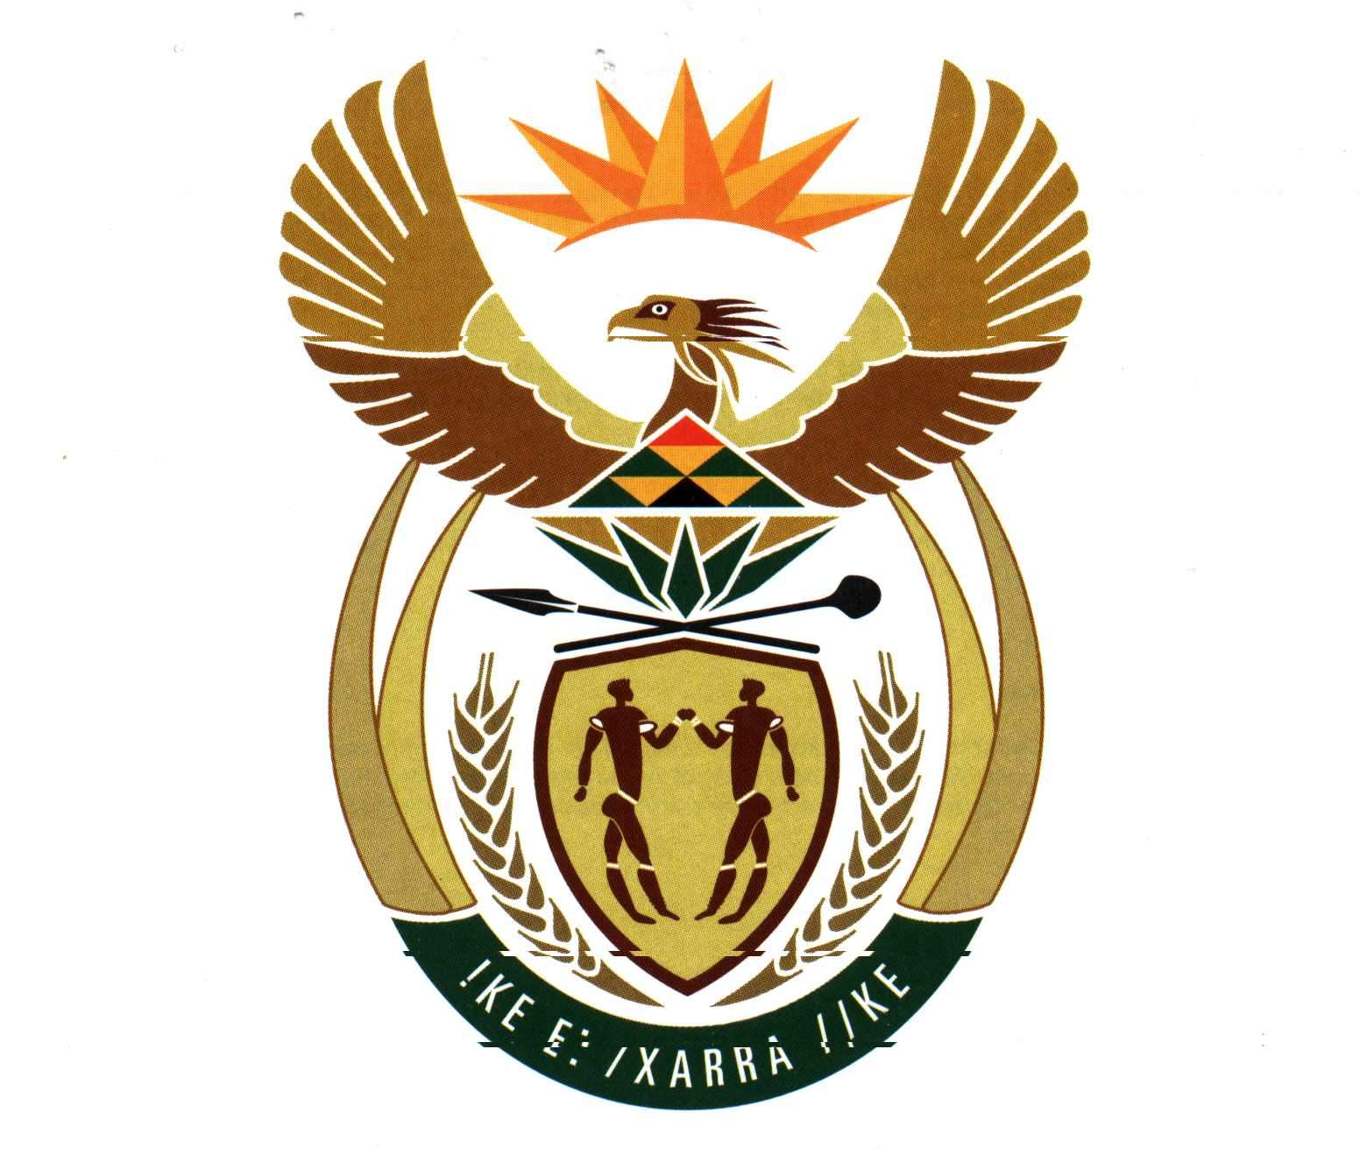

NATIONAL DEPARTMENT OF AGRICULTURE

IMPORT MANUAL

FOR PARTICIPANTS OF

THE IMPORT TRADE

INDEX

- Introduction

- Initial Approval of import

- Import of consignment

- Fees

- Names and telephone numbers of contact persons at the Regional Offices of Quality Audit

6. Service Excellence – Positive Criticism

- INTRODUCTION

As you are a prospective Importer of liquor products, we would like to introduce you to the Directorate Plant Health and Quality and supply you with certain guidelines regarding the import of liquor.

The Directorate is, amongst others responsible for enforcing the Liquor Products Act, (Act 60 of 1989). The office of division Liquor Products, where Import Certificates are issued, is situated at Quarantine Station outside Stellenbosch. The Quality Audit division, of the Directorate Plant Health and Quality is responsible for the inspection and sampling of liquor products and also issues various Import Certificates. (see paragraph 5 for contact persons and telephone numbers). Please note that there are other Departments which are also concerned with aspects of liquor imports and they may set additional requirements than those set by this Department under the abovementioned Act.

Import Certificate – obtained from Liquor Products Division
An Import Certificate is required in order to import a liquor product, in bulk/ bottles, (excluding beer) to South Africa. To release a consignment from Customs, the Import Certificate or a copy thereof will be required. Please note, an Importer apply for an Import Certificate only once in the lifetime of a product, after that the same Import Certificate number can be used provided that the composition, content, bottle size and label of that product doesn’t change.

- Certificate of Removal – obtained from the Quality Audit Division (wine inspectors)
This Certificate will be required when the Importer wants to sell the liquor product (only applicable to bottled products) in South Africa. A Certificate of Removal is required for each consignment.

- Permission for blending of liquor imported in bulk – obtained from Quality Audit Division
This certificate will be required when a liquor product are imported in bulk and the importer wants to blend the overseas product with a South African or another overseas product. The permission to blend will also be required if the importer wants to break down the bulk product with water.

- Permission to sell liquor imported in bulk after bottling – obtained from Quality
Audit Division
This certificate will be required if the Importer wants to sell the liquor product after blending and bottling. If a liquor product are imported in bulk and diluted with distillated water the above certificate will also be required.

- Import Certificate Exemption – obtained from Quality Audit Division
This certificate will be required if an Importer would like to import liquor products for any other purpose than the distribution and sale thereof in South Africa. The first 24 litre of a product are free, after that the Importer will pay a fee for every litre that exceeds the amount of 24 litres.

Please note : An Import Certificate will not be required in respect of products with an alcohol content of more than one per cent that are imported for drinking purposes and form part of the personal luggage of a person who arrives in the Republic, provided such products

- in total do not exceed 12 litres in volume ;
- are intended solely for consumption by that person, his household and his non-paying guests.

Attached hereto please find application forms for the abovementioned certificates.

- INITIAL APPROVAL FOR IMPORT

2.1 An Import Certificate serves as preliminary approval to import a specific liquor product (bottled or bulk).

2.2 A separate Import Certificate is issued for every liquor product which differs from any other liquor product with regards to container, composition, labeling, trade name and bottle size. In case of a bulk import only the composition.

  - Each application should be accompanied by a sample consisting of at least 750 ml of the product in question, in case of a bottled import, the sample must be submitted in the labeled container in which it will be sold in the Republic. A bulk sample can be submitted in an ordinary 750 ml bottle. The importer must deliver this sample to the office of Division Liquor Products.

  - A chemical analysis will be performed on the sample, if the Importer cannot provide this office with an acceptable Analysis Certificate issued by an Official Laboratory in the country of origin. In case of a bottled import, the label on the bottle will be evaluated to ensure its compliance with the requirements of Act 60/1989. With a bulk import the content will be evaluated and the label is evaluated when the application is made for a permission to sell certificate.

  - An Import Certificate will be issued if the content/label, in case of a bottled import, and the content, in case of a bulk import, of a product comply with the requirements of the Act. A consignment of the product may then be imported according to the procedure laid down below.

- IMPORT OF CONSIGNMENT

3.1 At least 48 hours notice must be given to the Quality Audit division every time a consignment of liquor, for which an Import Certificate has been issued, will enter this country.

  - When liquor products arrive in the Republic, the Importer must obtain a pass from Quality Audit to remove the liquor from the port area/container depot to a site of his/her choice.

  - Certificate of Removal – bottled products

The consignment of liquor must be unpacked under supervision of an Inspector from Quality Audit. An Application for a Certificate of Removal must be handed to the Inspector at this point in time. A separate application for a Certificate of Removal must be completed for every liquor product which differ from any other liquor product with regards to container, composition, labeling, trade name and bottle size.
The application for a certificate of Removal must be accompanied by :

    - A sample (with a minimum volume of 750 ml) which was drawn from the consignment by an Inspector of the Directorate.

    - The necessary certificates of origin, age, composition/cultivar as specified in Act 60 of 1989.

  - Permission for blending of liquor imported in bulk and Permission to sell liquor imported in bulk after bottling

The consignment must also be unpacked under supervision of an Inspector of the Directorate. When an imported product are going to be blended with a South African or another overseas product, the Importer must fill in an application for Permission to Blend, and submit it to the Inspector. In case of a bulk product that are imported and just diluted with water an application for Permission to Blend will also be required. The application for Permission to Blend must be accompanied by :

    - A 750 ml sample which was drawn from the consignment by an Inspector of the Directorate.

    - The necessary Certificates of Origin, Age, Composition and Cultivar as specified in Act 60 of 1989. It should be noted, that the above certificates will only comply if they are issued by the Official Body in the country of origin.

The Inspector will notify the importer that he can continue to blend the overseas product with the South African/another overseas product. The Inspector will come and draw a sample of the blended product and submit it to the Laboratory for analysis. If the content of the blended product complies the Importer can bottle and label the final product. The Inspector will draw a sample of the final product, at this stage the Importer must apply for Permission to sell liquor imported in bulk after bottling.
In case of a product, diluted with water the importer can only notify the Inspector when he is ready to submit a final product. The inspector will then draw the final product. The Importer will apply for a Final Permission to sell after bottling at this point.

  - The sealed sample are delivered to the office of Quality Audit Services by the inspector himself, if the port of entry is in Cape Town. Otherwise the sealed sample, that was drawn by an Inspector of the Directorate in that Region, must be send to the Quality Audit (South) office by the importer himself.

  - After a chemical analysis and confirmation that the content and labeling complies with the requirements of Act 60/1989, an Inspector will issue a Certificate of Removal/Permission to sell Liquor imported in bulk after bottling.

  - After having received the above certificates the Importer may distribute and sell the liquor.

- FEES

4.1 Import Certificate (bottle) - R55-00
Import Certificate (bulk) - R145-00
Analysis of Import sample - R240
Plus analysis fee as per general liquor analysis tariffs (levied by Analytical Services South by means of an invoice)

Please note, if the importer provides the office of the Administering Officer with an acceptable Analysis Certificate, issued by an Official Laboratory in the country of origin, he/she will be exempted from the R240-00. Lists of the Official Laboratories in the different countries can be obtained from Marian Honing, Telephone number : 021-8091687 or e-mail : marianh@nda.agric.za

4.2 Certificate of Removal - R40-00 + R2-20 per hl or a portion thereof

4.3 Permission to Blend - R400 per application + analysis fee as
as per general liquor analysis tariffs.

4.4 Permission to Sell - R400 per application + analysis fee as per general liquor analysis tariffs

4.5 B code number - R33-00 per application

4.6 Annual maintenance for a B code number R100-00

4.7 Import Certificate Exemption - R7-00 per litre or a portion thereof.

  - Exemption from payment of fees

- a liquor products produced and bottled in the Republic as well as the first 180 litres of other products is exempted from fees, provided the applicant concerned is an officer who served overseas in a diplomatic capacity and returns to the Republic after completion of his term of duty :

- or, a product intended to be utilized for scientific purposes :

- or, a product in respect of which exemption from the submission of a sample in terms of regulation 45(1)(b) has been granted : “A sample of a product shall not be required in the case of an application for an import certificate –

- when of a product is intended for consumption solely by the applicant concerned, his household and his non-paying guests or as a bona fide trade sample, provided –

- the liquor product and does not exceed 24 litres in volume.
- Such volume together with the total volume of liquor products imported by that applicant during the 12 months preceding his application under such exemption, does not exceed 180 litres in volume.”

(d) or, products in respect of which an application was made under the circumstances set out in regulation 43(4) “If a person intends to move to the Republic, one application may be submitted by him in respect of all the products forming part of his household or personal effects, provided –

- that person was not resident in the Republic during the 12 months preceding his application :
- the volume of those products, excluding products produced and bottled in the Republic, that differ in respect of container, composition and labeling, does not exceed 24 litres each ; and
- the application concerned is also accompanied by –

- an inventory in which full particulars of the products concerned are furnished :
- evidence of the fact specified in paragraph (a) ; and
- a written undertaking by the applicant concerned that he will not sell those products in the Republic.”

5. NAMES AND TELEPHONE NUMBERS OF CONTACT PERSONS AT THE REGIONAL OFFICES OF QUALITY AUDIT

Johannesburg International 011-9703130 Mrr. Thys Louw/Gilbert Mediroe
Nelspruit 013-7554527 Mr L C Changuion
Bloemfontein 051-4476227 Mr S du Preez
Durban 031-3372755 Mr S Strydom
Port Elizabeth 041-4842725 Mr T van Niekerk
East London 043-7221978 Mr L Venter
Oudtshoorn 044-2791744 Mr P Erasmus
Stellenbosch 021-8091704 Mr G van Wyk
Cape Town 021-8091704 Mr G van Wyk
Upington 054-3340529 Mr J Cilliers

- SERVICE EXCELLENCE – POSITIVE CRITICISM

In order for us to provide our clients with excellent service, it is necessary for us to know what our weaknesses and strengths are. We therefore invite clients to e-mail, contact or fax us with comments, complaints, observations etc. which we could address in a constructive manner. Please address all correspondence to Marian Honing at telephone no : 021-8091687, fax no : 021-8876396/2 or e-mail to marianh@nda.agric.za

