Cowpea/Akkerboon, 2001-04-04

Reference Number/Verwysingsnommer
(for office use/vir kantoorgebruik)

TECHNICAL QUESTIONNAIRE
to be completed in connection with an application for a plant breeder’s right
and/or recognition of a variety

TEGNIESE VRAELYS
om saam met ‘n aansoek om planttelersregte en/of variëteitserkenning voltooi te word
1. Species/Spesie Vigna spp. (specify please)

COWPEA

AKKERBOON

- Applicant (Name and address of local company/organisation)
Aansoeker (Naam en addres van plaaslike firma/organisasie)

Tel.: ……………………………. Fax/Faks: ………………………….
Contact person/Kontakpersoon: …………………………………………… ……….
E-mail: ………………………………………………………………………………..
- Proposed denomination or breeder’s reference

Voorgestelde benaming of telersverwysing

4. Information on origin, maintenance and reproduction of the variety

Inligting oor oorsprong, instandhouding en voortplanting van die variëteit

4.1 Reproduction and maintenance/Voortplanting en instandhouding
i) Hybrid/Baster [ ]
ii) Open-pollinated variety/Oopbestuifde variëteit [ ]
4.2 Origin/Oorsprong
i) Imported from/Ingevoer vanaf …………………………………………..
OR/OF
ii) Bred locally/Plaaslik geteel [ ]
  - Genetic manipulated organisms/Geneties gemanipuleerde organismes
- Was genetic manipulation used in the breeding program?/ Yes/Ja[ ]
Is genetiese manipulering betrokke? No/Nee[ ]
- Specify the organism from which the genetic material originated/
Spesifiseer die organisme waarvandaan die genetiese materiaal verkry is
…………………………………………………………………………………………..
…………………………………………………………………………………………..
…………………………………………………………………………………………..
4.4 Other information
Has this variety been sold or marketed in South Africa previously?
Is hierdie variëteit al voorheen in Suid-Afrika verkoop of bemark?
Yes/Ja [ ] No/Nee [ ]
If yes, indicate where and when/Indien ja, dui aan waar en wanneer:
………………………………………………………………….
………………………………………………………………….

- Characteristics of the variety to be indicated (the number in brackets refers to the corresponding characteristic in the Test Guidelines; please mark the state of expression which best corresponds)./
Kenmerke van die variëteit wat aangetoon moet word (die nommer in hakies verwys na die ooreenstemmende kenmerk in die UPOV-riglyne); merk asseblief in die toepaslike spasie by die ooreenstemmende kenmerk.

 | CHARACTERISTICS /  KENMERKE | NOTE/  NOTA
5.1 | Plant: habit of growth | erect/regop | 1 [ ]
(2) | Plant: groeiwyse | intermediate/intermediêr | 2 [ ]
 |  | creeping/kruipend | 3 [ ]
 |  | climbing/rankend (develop | 4 [ ]
 |  | tendrils/ontwikkel klimranke)
5.2 | Plant: anthocyanin colouration | absent/afwesig | 1 [ ]
(8) | (6 weeks after planting) | light/lig | 3 [ ]
 | Plant: antosianien-verkleuring | medium | 5 [ ]
 | (6 weke na plant) | dark/donker | 7 [ ]
5.3 | Terminal leaflet: shape 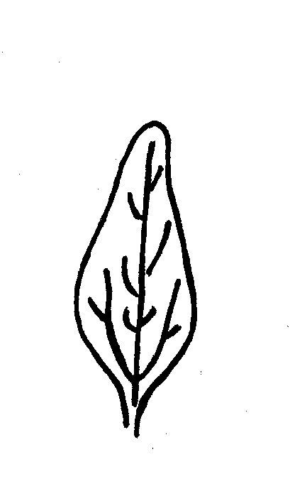 | lanceolate/lansetvormig | 1 [ ]
(12) | Terminale pinna: vorm 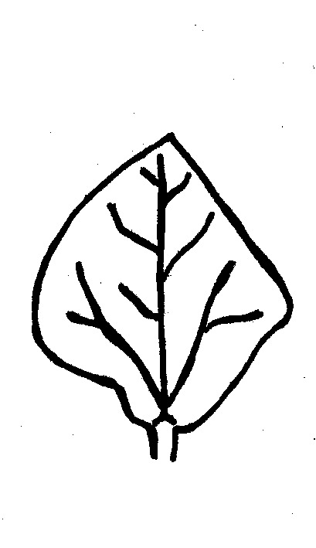 | rhombic/ruitvormig | 2 [ ]
 | 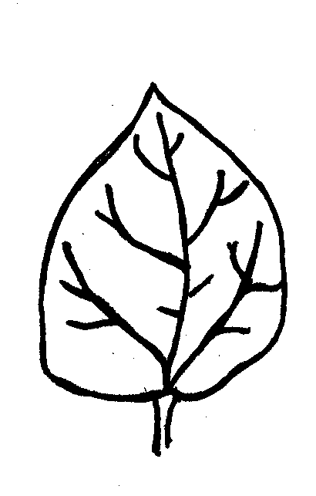 | ovate/eiervormig | 3 [ ]
 | 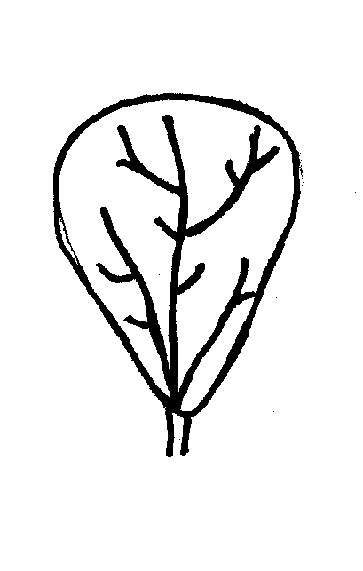 | obovate/omgekeerd eiervormig | 4 [ ]
 | 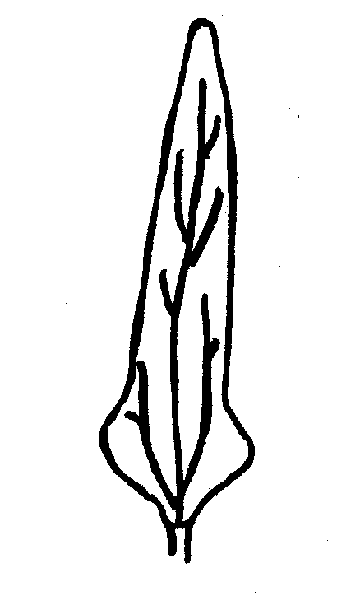 | finger shaped/vingervormig | 5 [ ]
 |  | other/ander | 6 [ ]
 |  | Specify/Spesifiseer
 |  | ………………………………………...
5.4 | Inflorescence: location | between foliage/tussen blare | 1 [ ]
(15) | (at full flowering) | Partly between foliage/
 | Bloeiwyse: posisie | deels tussen blare | 2 [ ]
 | (tydens blom) | Above foliage/bokant blare | 3 [ ]
5.5 | Flower: colour | monocoloured/eenkleurig | 1 [ ]
(16) | Blom: kleur | multicoloured/meerkleurig | 2 [ ]
5.6 | Flower: distribution of colour | in v-shape/in v-vorm | 1 [ ]
(17) | on standard | marginally/op rand | 2 [ ]
 | Blom: verspreiding van kleur | whole standard/oor hele vlagblaar | 3 [ ]
 | op vlagblaar
5.7 | Flower: distribution of colour | marginally/op rand | 1 [ ]
(18) | on wing | whole wing/oor hele vlerk | 2 [ ]
 | Blom: verspreiding van kleur | Other/ander | 3 [ ]
 | op vlerke | Specify/Spesifiseer
 |  | ………………………………………...
5.8 | Pod: anthocyanin colouration | absent/afwesig | 1 [ ]
 | (green pod stage) | present/aanwesig | 9 [ ]
 | Peul: antosianienverkleuring
 | (groenpeul stadium)
5.9 | Pod: distribution of anthocyanin | on tip of pod/op peulpunt | 1 [ ]
(20) | colouration (if present) | on seam and tip of pod/
 | Peul: verspreiding van antosianien | op peulnaat en –punt | 2 [ ]
 | verkleuring (indien aanwesig) | on lemma/op lemma | 3 [ ]
 |  | in dots/in spikkels | 4 [ ]
 |  | evenly over whole pod/
 |  | eenvormig oor hele peul | 5 [ ]
5.10 | Pod: number of locules | X = …………………………………...
(21) | (green pod stage) | few/min | 3 [ ]
 | Peul: aantal saadhokke | medium | 5 [ ]
 | (groenpeul stadium) | many/baie | 7 [ ]
5.11 | Pod: attitude | erect/regop | 1 [ ]
(22) | Peul: houding | horizontal/horisontaal | 2 [ ]
 |  | drooping/hangend | 3 [ ]
5.12 | Pod: shape of curvature 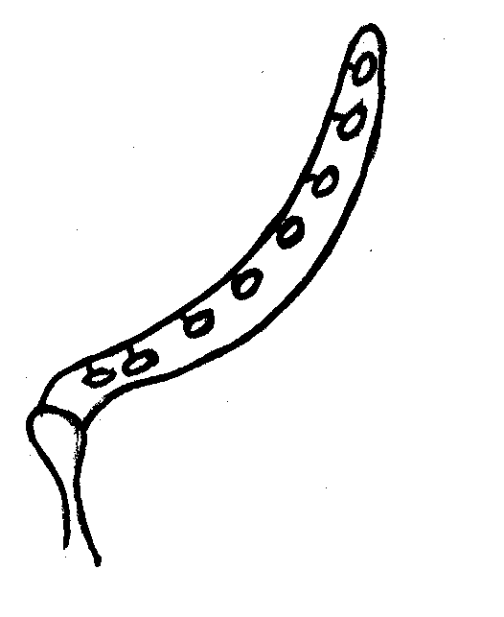 | concave/konkaaf | 1 [ ]
(24) | Peul: vorm van kromming 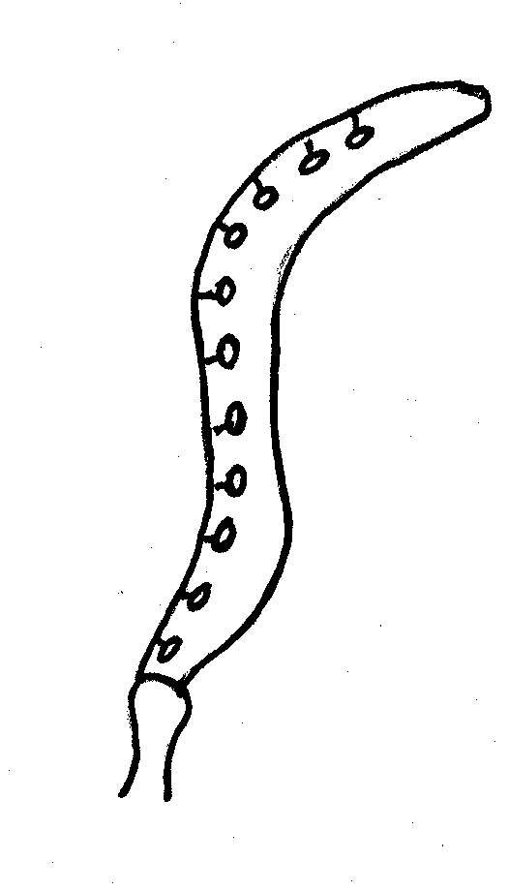 | s-shaped/s-vormig | 2 [ ]
 | 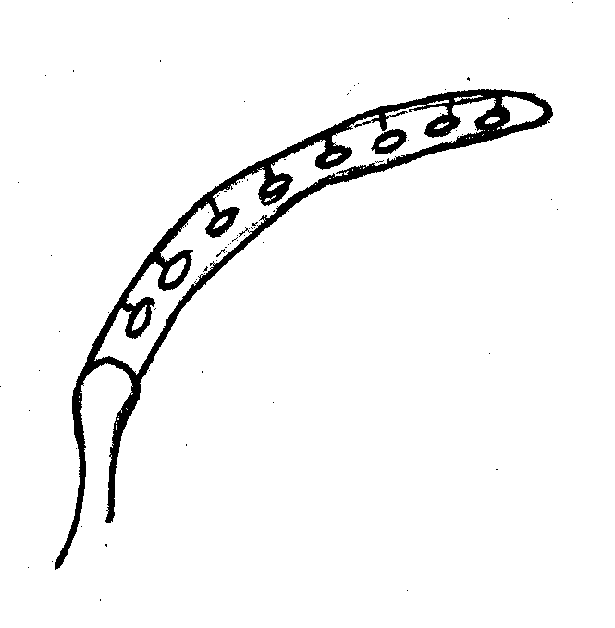 | convex/konveks | 3 [ ]
5.13 | Pod: dehiscence (harvest mature) | absent/afwesig | 1 [ ]
(29) | Peul: oopspringendheid (oesryp) | present/aanwesig | 9 [ ]
5.14 | Seed: number of colours | one/een | 1 [ ]
(31) | (in dry stage, hilum excluded) | two/twee | 2 [ ]
 | Saad: aantal kleure | more than two/meer as twee | 3 [ ]
 | (op droë stadium, hilum uitgesluit)
5.15 | Seed: ground colour (largest area) | white/wit | 1 [ ]
(32) | Saad: grondkleur (grootste area) | cream/room | 2 [ ]
 |  | grey/grys | 3 [ ]
 |  | brownish/bruinerig | 4 [ ]
 |  | purple/pers | 5 [ ]
 |  | red/rooi | 6 [ ]
 |  | black/swart | 7 [ ]

6. Similar varieties and differences from these varieties (varieties known in South Africa)

Soortgelyke variëteite en verskille van hierdie variëteite (variëteite bekend in Suid-Afrika)
Denomination of similar variety / Benaming van soortgelyke variëteit | Characteristic in which the similar variety is different* / Kenmerk waarin soortgelyke variëteit verskil*) | State of expression of similar variety / Uiting van kenmerk van soortgelyke variëteit | State of expression of candidate variety / Uiting van kenmerk van kandidaat variëteit
* In the case of identical states of expressions of both varieties, please indicate the size of the difference.
In geval van identiese uiting van kenmerke van beide variëteite, dui asb. die grootte van die verskil aan.
7. Additional information which may help to distinguish the variety/

Addisionele inligting wat kan help om die variëteit te onderskei
7.1 Resistance to pests and diseases/Weerstand teen siektes en plae
…………………………………………………………………………………………….
…………………………………………………………………………………………….
…………………………………………………………………………………………….
…………………………………………………………………………………………….
7.2 Special conditions for the examination of the variety

Spesiale toestande vir die ondersoek van die variëteit
……………………………………………………………………………………………
……………………………………………………………………………………………
7.3 Other information
……………………………………………………………………………………………
……………………………………………………………………………………………

8. Authorization for release/Magtiging vir vrystelling
(a) Does the variety require prior authorization for the release under legislation concerning the protection of the environment, human and animal health?
Benodig die variëteit vooraf magtiging vir vrystelling onder wetgewing wat die omgewing, mens- en dieregesondheid beskerm?
Yes/Ja [ ] No/Nee [ ]
(b) Has such authorization been obtained?
Is sulke magtiging verkry?
Yes/Ja [ ] No/Nee [ ]
If the answer to that question is yes, please attach a copy of such an authorization.
Indien die antwoord ja is, heg asseblief ‘n afskrif van die magtiging aan.

Signature ……………………………………….. Date ………..…………………
Handtekening Datum

