TECHNICAL QUESTIONNAIRE |  |  |  |  |  | Reference Number:
 |  |  |  |  |  | Application date:
 |  |  |  |  |  | (not to be filled in by the applicant)
TECHNICAL QUESTIONNAIRE
to be completed in connection with an application for plant breeders’ rights and variety listing

1. Subject of the Technical Questionnaire
1.1 Botanical name |  |  | Vitis L.
1.2 Common Name |  |  | GRAPEVINE
2.1 Species |  |  | Vitis vinifera L.
2.2 Other species
2. Applicant
Name
Address
Telephone No.
Fax No.
E-mail address
Breeder (if different from applicant)
3. Proposed denomination and breeder’s reference
Proposed denomination
(if available)

Breeder’s reference
4. Information on the breeding scheme and propagation of the variety

4.1 Origin of variety

(a) imported from: ………………………………………. [ ]
OR
(b) bred in South Africa [ ]

4.2 Variety resulting from:
4.2.1 Crossing
(a) controlled cross (please state parent varieties) [ ]
……………………………………………………………..
(b) partially known cross (please state known parent variety) [ ]
……………………………………………………………..
(c) unknown cross [ ]
4.2.2 Mutation (please state parent variety) [ ]
………………………………………………………………….
4.2.3 Discovery and development [ ]
(please state where and when discovered and how developed)
4.2.4 Other (please provide details) [ ]

4.3 Method of propagating the variety)

4.4 Other information

(a) Has this variety been sold or marketed in South Africa previously?

Yes [ ] No [ ]

If yes, indicate where and when

………………………………………………………………….

5. Characteristics of the variety to be indicated (the number in brackets refers to the corresponding characteristic in Test Guidelines; please mark the note which best corresponds).

 | Characteristics |  |  |  |  |  | Example Varieties |  |  | Note
5.1  (3) | Young shoot: openness of tip  closed  slightly open  half open  wide open  fully open |  |  |  |  |  |  |  |  | 1[ ]  2[ ]  3[ ]  4[ ]  5[ ]
5.2  (18) | Flower: sexual organs  fully developed stamens and no gynoecium  fully developed stamens and reduced gynoecium  fully developed stamens and fully developed gynoecium  reflexed stamens and fully developed gynoecium |  |  |  |  |  |  |  |  | 1[ ]  2[ ]  3[ ]  4[ ]
5.3  (23) | Mature leaf: number of lobes  none  three  five  seven  more than seven |  |  |  |  |  |  |  |  | 1[ ]  2[ ]  3[ ]  4[ ]  5[ ]
5.4  (26) | Mature leaf: arrangement of lobes of petiole sinus  very wide open  wide open  half open  slightly open  closed  slightly overlapped  half overlapped  strongly overlapped  very strongly overlapped |  |  |  |  |  |  |  |  | 1[ ]  2[ ]  3[ ]  4[ ]  5[ ]  6[ ]  7[ ]  8[ ]  9[ ]
 | Characteristics |  |  |  |  |  | Example Varieties |  |  | Note
5.5  (35) | Only varieties for fruit production: Time of berry ripening  Date: ………………………………  very early  early  medium  late  very late |  |  |  |  |  |  |  |  | 1[ ]  3[ ]  5[ ]  7[ ]  9[ ]
5.6  (40) | Berry: shape in profile  oblong 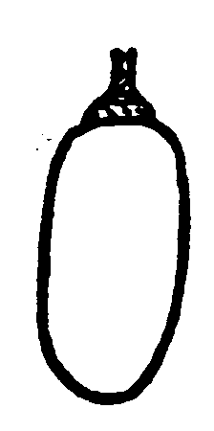  elliptic 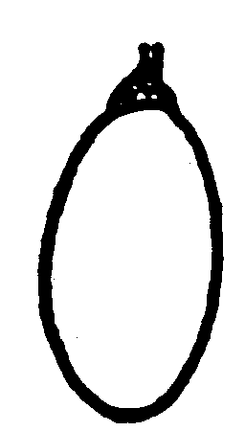  broad elliptic 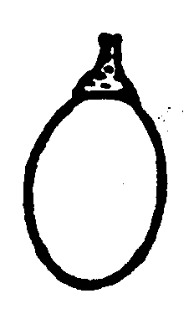  circular 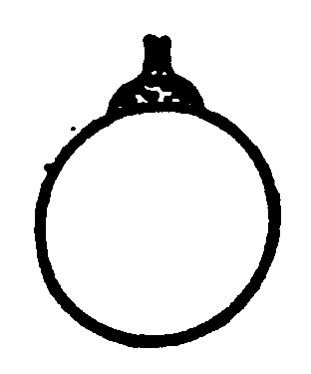  oblate 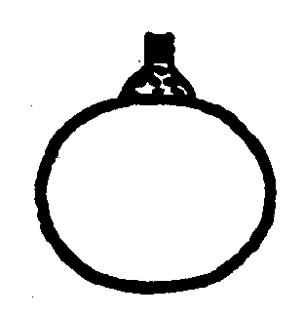  ovate 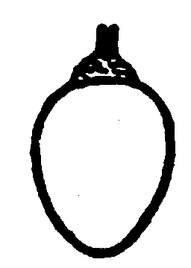  obtuse ovate 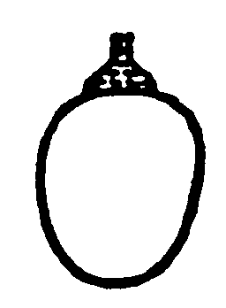  obovate 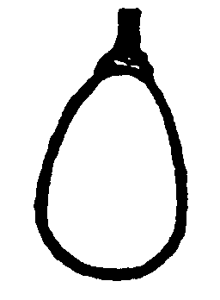  corniform 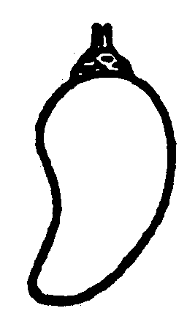 |  |  |  |  |  |  |  |  | 1[ ]  2[ ]  3[ ]  4[ ]  5[ ]  6[ ]  7[ ]  8[ ]  9[ ]
5.7  (41) | Berry: color of skin (without bloom)  yellow green  rose  red  grey red  dark red violet  blue black |  |  |  |  |  |  |  |  | 1[ ]  2[ ]  3[ ]  4[ ]  5[ ]  6[ ]
 | Characteristics |  |  |  |  |  | Example Varieties |  |  | Note
5.8  (44) | Berry: anthocyanin coloration of flesh  absent or very weak  weak  medium  strong  very strong |  |  |  |  |  |  |  |  | 1[ ]  3[ ]  5[ ]  7[ ]  9[ ]
5.9  (47) | Berry: particular flavor  none  muscat  foxy  herbaceous  other than muscat, foxy or herbaceous |  |  |  |  |  |  |  |  | 1[ ]  2[ ]  3[ ]  4[ ]  5[ ]
5.10  (48) | Berry: presence of seed  absent  rudimentary  complete |  |  |  |  |  |  |  |  | 1[ ]  2[ ]  3[ ]
6. Similar varieties and differences from these varieties

Please use the following table and box for comments to provide information on how your candidate variety differs from the variety (or varieties) which, to the best of your knowledge, is (or are) most similar. This information may help the examination authority to conduct its examination of distinctness in a more efficient way.

Denomination(s) of variety(ies) similar to your candidate variety |  | Characteristic(s) in which your candidate variety differs from the similar variety(ies) |  |  | Describe the expression of the characteristic(s) for the similar variety(ies) |  |  | Describe the expression of the characteristic(s) for your candidate variety
Example |  | Berry: shape in profile |  |  | obovate |  |  | circular
Comments:

7. Additional information which may help in the examination of the variety

7.1 In addition to the information provided in sections 5 and 6, are there any additional characteristics which may help to distinguish the variety?
Yes [ ] No [ ]
(If yes, please provide details)

7.2 Are there any special conditions for growing the variety or conducting the examination?

7.2.1 Fungicide treatment is necessary against the following diseases:
yes no sometimes unknown
- Peronospora (Plasmopara) [ ] [ ] [ ] [ ]
- Oidium [ ] [ ] [ ] [ ]
- Botrytis [ ] [ ] [ ] [ ]

7.2.2 Are there any other special conditions?
Yes [ ] No [ ]
(If yes, please provide details)

7.3 Other information

7.3.1 Main use
(a) wine grape [ ]
(b) table grape [ ]
(c) rootstock [ ]
(d) ornamental [ ]
(e) other (specify) [ ]
……………………………………..

A representative color photograph of the variety should accompany the Technical Questionnaire

8. Authorization for release

(a) Does the variety require prior authorization for release under legislation concerning the protection of the environment, human and animal health?
Yes [ ] No [ ]

(b) Has such authorization been obtained?
Yes [ ] No [ ]
If the answer to (b) is yes, please attach a copy of the authorization.

9. Information on plant material to be examined or submitted for examination.

9.1 The expression of a characteristic or several characteristics of a variety may be affected by factors, such as pests and disease, chemical treatment (e.g. growth retardants or pesticides), effects of tissue culture, different rootstocks, scions taken from different growth phases of a tree, etc.

9.2 The plant material should not have undergone any treatment which would affect the expression of the characteristics of the variety, unless the competent authorities allow or request such treatment. If the plant material has undergone such treatment, full details of the treatment must be given. In this respect, please indicate below, to the best of your knowledge, if the plant material to be examined has been subjected to:

(a) Microorganisms (e.g. virus, bacteria, phytoplasma) Yes [ ] No [ ]
(b) Chemical treatment (e.g. growth retardant, pesticide) Yes [ ] No [ ]
(c) Tissue culture Yes [ ] No [ ]
(d) Other factors Yes [ ] No [ ]
Please provide details on a separate page of where you have indicated “yes”.

9.3 Has the plant material to be examined been tested for the presence of virus or other pathogens?

Mother plants of the variety:
Yes [ ]
(please provide details of tests and results)
No [ ]
Mother plants of rootstock in case of grafted plants:
Yes [ ]
(please provide details of tests and results)
No [ ]

10. I hereby declare that, to the best of my knowledge, the information provided in this form is correct:

Applicant’s name

Signature Date

