TG/128/3 & IPCR
Leucospermum, 2003-10-07

Reference Number/Verwysingsnommer
(for office use/vir kantoorgebruik)

TECHNICAL QUESTIONNAIRE
to be completed in connection with an application for a plant breeder’s right
and registration in the International Proteaceae Cultivar Register

TEGNIESE VRAELYS
om saam met ‘n aansoek om planttelersregte voltooi te word asook vir registrasie in die
Internasionale Proteaceae Cultivar Register
1.1 Genus Leucospermum R.Br.

PINCUSHION

SPELDEKUSSING
1.2 Species/Spesie ………………………………………………..

- Applicant (Name and address of local company/organisation)
Aansoeker (Naam en addres van plaaslike firma/organisasie)

Tel.: ……………………………. Fax/Faks: ………………………….
Contact person/Kontakpersoon: …………………………………………………….
- Proposed denomination or breeder’s reference

Voorgestelde benaming of telersverwysing

Commercial name (if applicable)
Kommersiële naam (indien van toepassing)

4. Information on origin, maintenance and reproduction of the variety

Inligting oor oorsprong, instandhouding en voortplanting van die variëteit

4.1 Origin/Oorsprong
(a) Seedling (indicate parent varieties)/ Saailing (dui ouervariëteite aan) [ ]
……………………………………………………………………….
(b) Mutation (indicate parent variety)/ Mutasie (dui ouervariëteit aan) [ ]
……………………………………………………………………….
(c) Discovery (indicate where and when)/ Ontdekking (dui aan waar en wanneer) [ ]
……………………………………………………………………….
(d) Other (specify)/Ander (spesifiseer) [ ]
……………………………………………………………………….
4.2 Method of reproduction/Metode van vermeerdering
- cuttings/steggies [ ]
- in vitro propagation/vermeerdering [ ]
- other (state method)/ander (dui metode aan) [ ]
4.3 Other information (only for PBR applications in South Africa)
Ander inligting (slegs vir PT aansoeke in Suid-Afrika)
(a) propagating material was imported from/ [ ]
voortplantingsmateriaal is ingevoer vanaf ……………………………………….
locally bred /plaaslik geteel [ ]
(b) Has this variety been sold or marketed in South Africa previously?
Is hierdie variëteit al voorheen in Suid-Afrika verkoop of bemark?
Yes/Ja [ ] No/Nee [ ]
If yes, indicate where and when/Indien ja, dui aan waar en wanneer:
………………………………………………………………….

5. Characteristics of the variety to be indicated (the number in brackets refers to the corresponding characteristic in the Test Guidelines; please mark the state of expression which best corresponds)./ Kenmerke van die variëteit wat aangetoon moet word (die nommer in hakies verwys na die ooreenstemmende kenmerk in die UPOV-riglyne; merk asseblief in die toepaslike spasie by die ooreenstemmende kenmerk.)

Characteristics/ Example Varieties/ Note/
Kenmerke Voorbeelde Nota
5.1 Plant: growth habit/Plant: groeiwyse
(1) upright/regop 3[ ]
spreading/spreidend 5[ ]
prostrate/platgroeiend 7[ ]
5.2 Plant: lignotuber/ Plant: verhoute stingel
(5) absent/afwesig 1[ ]
present/teenwoordig 9[ ]
5.3 Leaf: length (in mm)
(10) Blaar: lengte (in mm) …………………………………… mm
5.4 Leaf: width (in mm)
(11) Blaar: wydte (in mm) …………………………………… mm
5.5 Leaf: position of broadest part
(13) Blaar: posisie van maksimum breedte
below middle/onderkant die middle 1[ ]
in middle/in die middle 2[ ]
above middle/bokant die middle 3[ ]
along most of the length/oor die hele lengte 4[ ]
5.6 Leaf: shape of apex/Blaar: vorm van punt
(14) long acute/lank gespits 1[ ]
acute/spits 2[ ]
obtuse/stomp 3[ ]
rounded/gerond 4[ ]
truncate/afgestomp 5[ ]
5.7 Leaf: shape of base/Blaar: vorm van basis
(15) tapered/vernouend spits 1[ ]
acute/spits 2[ ]
obtuse/stomp 3[ ]
rounded/gerund 4[ ]
truncate/afgestomp 5[ ]
cordate/hartvormig 6[ ]

5.8 Leaf: color/Blaar: kleur
(17) grey/grys 1[ ]
grey green/grysgroen 2[ ]
yellow green/geelgroen 3[ ]
green/groen 4[ ]
dark green/donkergroen 5[ ]
5.9 Leaf: incisions on distal part/Blaar: insnydings of punt
(19) absent/afwesig 1[ ]
present/teenwoordig 9[ ]
5.10 Leaf: number of incisions on distal part (mature leaf tips on middle third of flowering branch)
(20) Blaar: aantal insnydings op punt (punte van volwasse blare op middelste derde van blomdraende loot)
very few/baie min 1[ ]
few/min 3[ ]
medium 5[ ]
many/baie 7[ ]
very many/uiters baie 9[ ]
5.11 Leaf: depth of incisions on distal part/Blaar: diepte van insnydings op punt
(21) shallow/vlak 3[ ]
medium 5[ ]
deep/diep 7[ ]
5.12 Leaf: color of callus on teeth/Blaar: kleur van kallus op tande
(22) yellowish/gelerig 1[ ]
brownish/bruinerig 2[ ]
reddish/rooierig 3[ ]
5.13 Flowering branch: clustering of fully developed flower heads
(34) Blomtak: groepvorming van volontwikkelde blomhofies
always absent/altyd afwesig 1[ ]
sometimes present/somtyds teenwoordig 2[ ]
always present/altyd teenwoordig 3[ ]
5.14 Flower head: length/ Blomhofie: lengte …………………………………….. cm
(37)
5.15 Flower head: diameter/ Blomhofie: deursnit …………………………………….. cm
(38)
5.16 Flower head: predominant color/ Blomhofie: oorwegende kleur RHS: …………………………………
(40) yellow/geel 1[ ]
orange/oranje 2[ ]
orange red/oranje-rooi 3[ ]
pink/pienk 4[ ]
red/rooi 5[ ]
5.17 Floret: color of rolled up perianth segment (“ribbons”)
(52) Blommetjie: kleur van opgerolde blomblaar (“linte”) RHS: …………………………………
yellow/geel 1[ ]
orange/oranje 2[ ]
orange red/oranje rooi 3[ ]
pink/pienk 4[ ]
red/rooi 5[ ]
5.18 Floret: intensity of color of ribbons/Blommetjie: intensiteit van linte se kleur
(53) pale/lig 3[ ]
medium 5[ ]
dark/donker 7[ ]
5.19 Floret: color of middle part of style
(58) Blommetjie: kleur van middelste deel van styl RHS: …………………………………
green 1[ ]
yellow 2[ ]
orange 3[ ]
orange red 4[ ]
pink 5[ ]
red 6[ ]
5.20 Floret: color of pollen presenter/Blommetjie: kleur van stuifmeelaanbieder
(62) yellow/geel 1[ ]
orange/oranje 2[ ]
orange red/oranje rooi 3[ ]
pink/pienk 4[ ]
red/rooi 5[ ]
5.21 Flowering season (months)/Blomseisoen (maande)
(64)
…………………………………………….
Southern Hemisphere /Suidelike Halfrond [ ]
Northern Hemisphere /Noordelike Halfrond [ ]

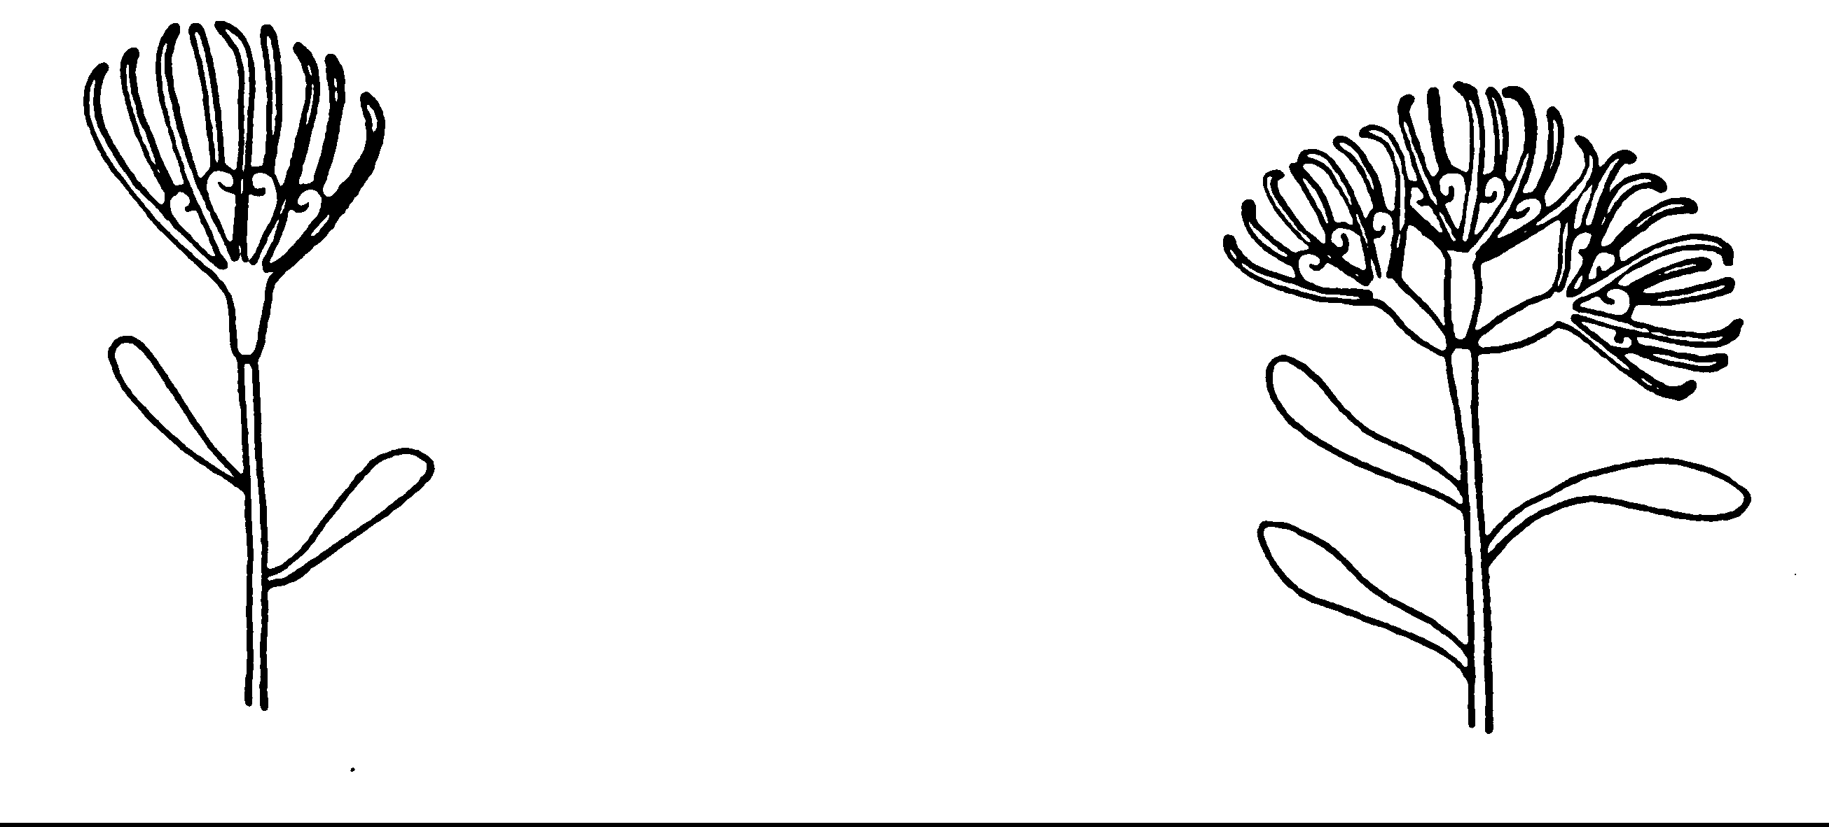Flower head: length and diameter/Blomhofie: lengte en wydte Flower head: clustering/Blomhofie: groepvorming
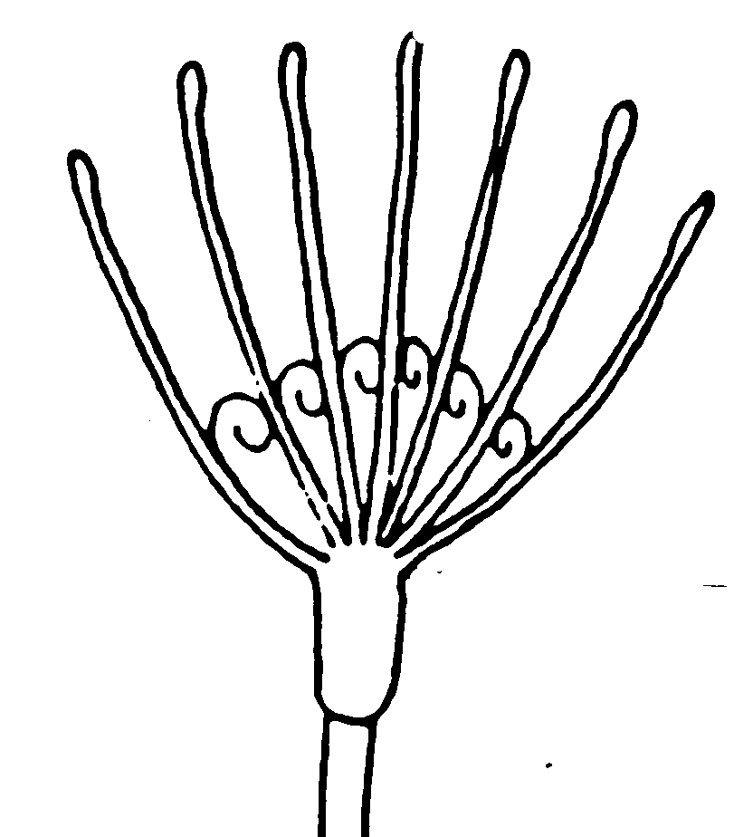
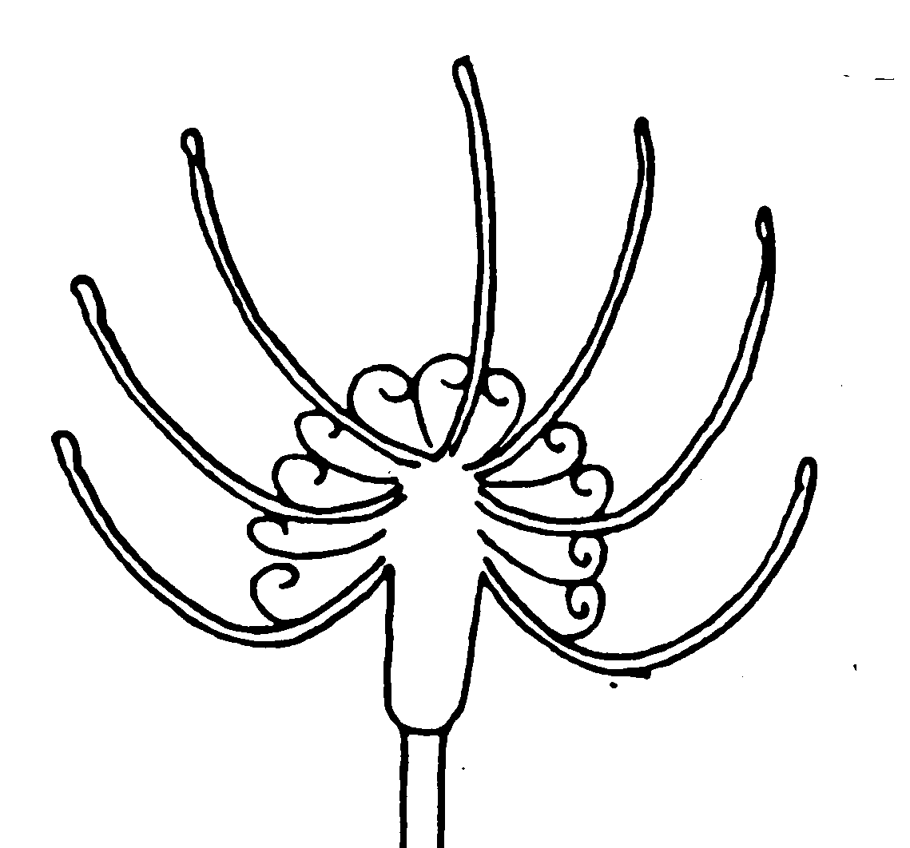
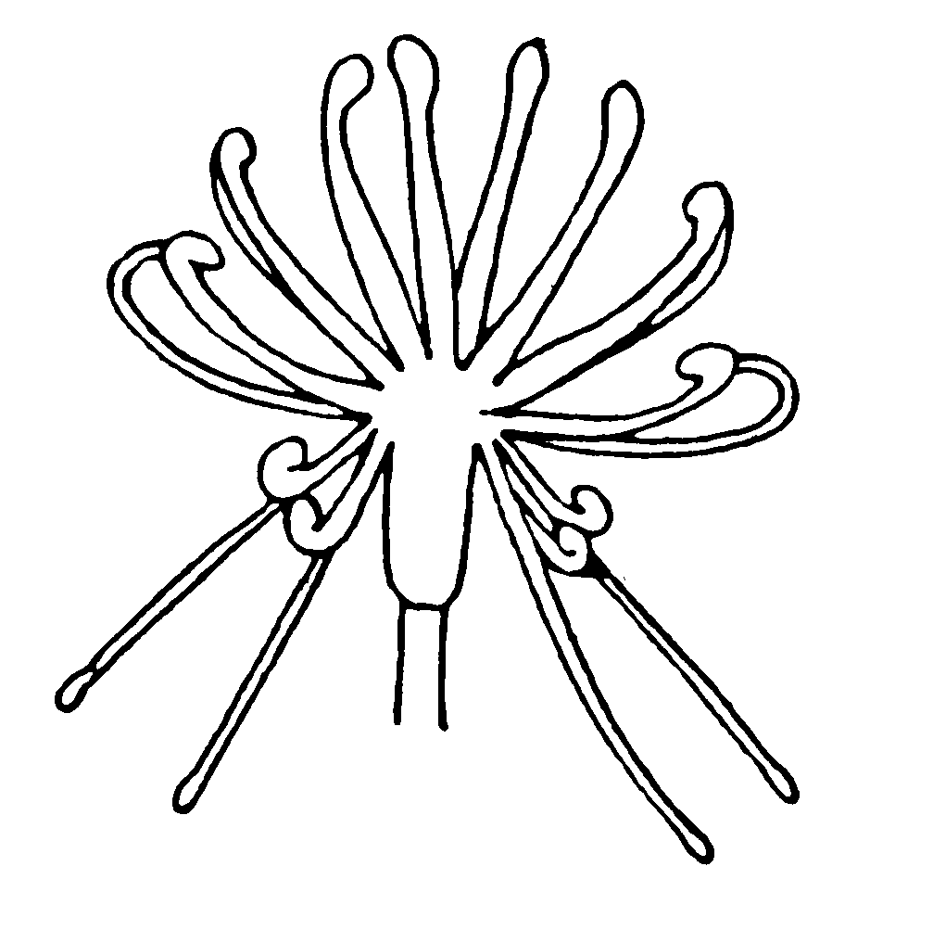
l
w
w
l
w
l
absent present

6. Similar varieties and differences from these varieties (varieties known in South Africa)

Soortgelyke variëteite en verskille van hierdie variëteite (variëteite bekend in Suid-Afrika)
Denomination of Characteristic in State of expression of State of expression of
similar variety/ which the similar similar variety/ candidate variety/
Benaming van soort- variety is different º)/ Uiting van kenmerk Uiting van kenmerk
gelyke variëteit Kenmerk waarin soort- van soortgelyke variëteit van kandidaatvariëteit
gelyke variëteit verskilº)

_____________________
º) In the case of identical states of expressions of both varieties, please indicate the size of the difference.
In geval van identiese uiting van kenmerke van beide variëteite, dui asb. die grootte van die verskil aan.
7. Additional information which may help to distinguish the variety/

Addisionele inligting wat kan help om die variëteit te onderskei
7.1 Resistance to pests and diseases/Weerstand teen siektes en plae

7.2 Special conditions for the examination of the variety

Spesiale vereistes vir die ondersoek van die variëteit

7.3 Other information/Ander inligting
(a) Use/Gebruik
(i) garden/tuin [ ]
(ii) pot plant/potplant [ ]
(iii) cut flower/snyblom [ ]
(iv) rootstock/onderstam [ ]
(v) other (specify)/ander(dui aan) [ ]
……………………………………………..
(b) Other/Ander

A representative color photo of the variety should be added to the Technical Questionnaire/
Sluit asb. ‘n verteenwoordigende kleurfoto van die variëteit by die Tegniese Vraelys in.

8. Authorization for release/Magtiging vir vrystelling
(a) Does the variety require prior authorization for the release under legislation concerning the protection of the environment, human and animal health?
Benodig die variëteit vooraf magtiging vir vrystelling onder wetgewing wat die omgewing, mens- en dieregesondheid beskerm?
Yes/Ja [ ] No/Nee [ ]
(b) Has such authorization been obtained?
Is sulke magtiging verkry?
Yes/Ja [ ] No/Nee [ ]
If the answer to that question is yes, please attach a copy of such an authorization.
Indien die antwoord ja is, heg asseblief ‘n afskrif van die magtiging aan.

Signature ……………………………………….. Date ………..…………………
Handtekening Datum

