 |  |  | Application date:
 |  |  | (not to be filled in by the applicant)
TECHNICAL QUESTIONNAIRE
to be completed in connection with an application for plant breeders’ rights

1. Subject of the Technical Questionnaire
1.1.1 Latin name | Brassica
1.1.2 Common Name | White Cabbage |  |  |  | [ ]
1.2.1 Latin Name | Brassica
1.2.2 Common Name | Savoy Cabbage |  |  |  | [ ]
1.3.1 Latin Name | Brassica
1.3.2 Common Name | Red Cabbage |  |  |  | [ ]
1.4.1 Hybrid between the species above
( please provide details)
2. Applicant
Name
Address
Telephone No.
Fax No.
E-mail address
Breeder (if different from applicant)
3. Proposed denomination and breeder’s reference
Proposed denomination
(if available)

Breeder’s reference
4. Information on the breeding scheme and propagation of the variety

4.1 Breeding scheme

Variety resulting from:

4.1.1 Crossing

(a) controlled cross [ ]
(please state parent varieties)
(b) partially known cross [ ]
(please state known parent variety(ies)
(c) unknown cross [ ]

4.1.2 Mutation [ ]
(please state parent variety)

4.1.3 Discovery and development [ ]
(please state where and when discovered
and how developed)

4.1.4 Other [ ]
(please provide details)

4.2 Method of propagating the variety

    - Seed-propagating varieties

(a) Self-pollination [ ]
(b) Cross-pollination
(i) population [ ]
(ii) synthetic variety [ ]
(c) Hybrid [ ]
(d) Other [ ]

4.2.2 Vegetatively propagated varieties [ ]

4.2.3 Other [ ]
(please provide details)

5. Characteristics of the variety to be indicated (the number in brackets refers to the corresponding characteristic in Test Guidelines; please mark the note which best corresponds).

5.1 a | White cabbage varieties only: Plant: height
(1.1) | very short |  |  |  |  | 1 [ ]
 | short |  |  |  |  | 3 [ ]
 | medium |  |  |  |  | 5 [ ]
 | tall |  |  |  |  | 7 [ ]
 | very tall |  |  |  |  | 9 [ ]
5.1 b | Red cabbage varieties only: Plant: height
(1.2) | very short |  |  |  |  | 1 [ ]
 | short |  |  |  |  | 3 [ ]
 | medium |  |  |  |  | 5 [ ]
 | tall |  |  |  |  | 7 [ ]
 | very tall |  |  |  |  | 9 [ ]
5.1 c | Savoy cabbage varieties only: Plant: height
(1.3) | very short |  |  |  |  | 1 [ ]
 | short |  |  |  |  | 3 [ ]
 | medium |  |  |  |  | 5 [ ]
 | tall |  |  |  |  | 7 [ ]
 | very tall |  |  |  |  | 9 [ ]
5.2 c | Savoy cabbage varieties only: Outer leaf: size
(5.3) | small |  |  |  |  | 3 [ ]
 | medium |  |  |  |  | 5 [ ]
 | large |  |  |  |  | 7 [ ]
5.3 a | White and Red cabbage varieties only: Outer leaf: degree of
(8.1) | blistering
 | Absent or weak |  |  |  |  | 1 [ ]
 | moderate |  |  |  |  | 2 [ ]
 | strong |  |  |  |  | 3 [ ]
5.3b | Savoy cabbage varieties only: Outer leaf: degree of blistering
(8.2) | absent or very weak |  |  |  |  | 1 [ ]
 | weak |  |  |  |  | 3 [ ]
 | medium |  |  |  |  | 5 [ ]
 | strong |  |  |  |  | 7 [ ]
 | very strong |  |  |  |  | 9 [ ]
5.4 | Outer leaf: color (with wax)
(11) | yellow green |  |  |  |  | 1 [ ]
 | green |  |  |  |  | 2 [ ]
 | grey green |  |  |  |  | 3 [ ]
 | blue green |  |  |  |  | 4 [ ]
 | violet |  |  |  |  | 5 [ ]
5.5 | Outer leaf: intensity of color
(12) | light |  |  |  |  | 3 [ ]
 | medium |  |  |  |  | 5 [ ]
 | dark |  |  |  |  | 7 [ ]
5.6 | Head: shape in longitudinal section
(17) | Transverse narrow elliptic |  |  | 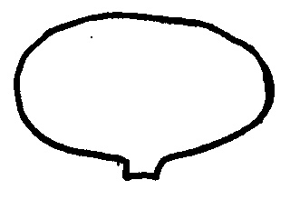 |  | 1 [ ]
 | Transverse elliptic |  |  | 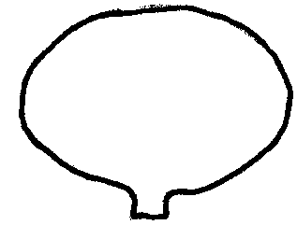 |  | 2 [ ]
 | Round/circular |  |  | 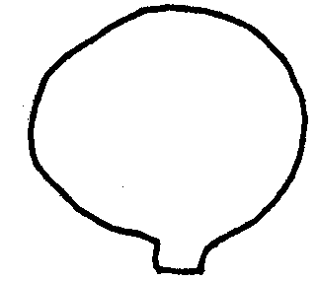 |  | 3 [ ]
 | Broad elliptic |  |  | 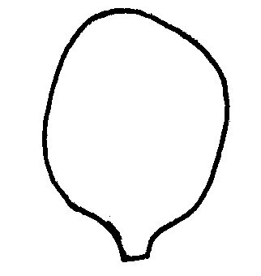 |  | 4 [ ]
 | Broad obovate |  |  | 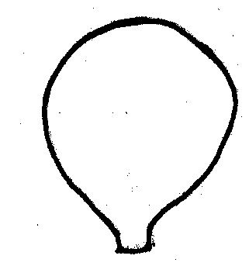 |  | 5 [ ]
 | Broad ovate |  |  |  |  | 6 [ ]
 | Angular ovate |  |  | 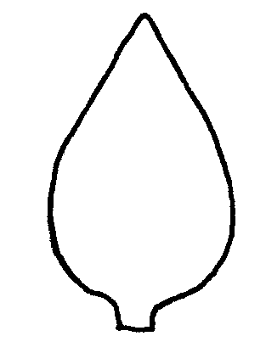 |  | 7 [ ]
5.7 | Head: diameter
(20) | small |  |  |  |  | 3 [ ]
 | medium |  |  |  |  | 5 [ ]
 | large |  |  |  |  | 7 [ ]
5.8 | Head: density
(30) | very loose |  |  |  |  | 1 [ ]
 | loose |  |  |  |  | 3 [ ]
 | medium |  |  |  |  | 5 [ ]
 | dense |  |  |  |  | 7 [ ]
 | very dense |  |  |  |  | 9 [ ]
5.9a | White cabbage varieties only: Time of harvest maturity
(33.1) | very early |  |  |  |  | 1 [ ]
 | early |  |  |  |  | 3 [ ]
 | medium |  |  |  |  | 5 [ ]
 | late |  |  |  |  | 7 [ ]
 | very late |  |  |  |  | 9 [ ]
5.9b | Red cabbage varieties only: Time of harvest maturity
(33.2) | early |  |  |  |  | 3 [ ]
 | medium |  |  |  |  | 5 [ ]
 | late |  |  |  |  | 7 [ ]
5.9c | Savoy cabbage varieties only: Time of harvest maturity
(33.3) | very early |  |  |  |  | 1 [ ]
 | early |  |  |  |  | 3 [ ]
 | medium |  |  |  |  | 5 [ ]
 | late |  |  |  |  | 7 [ ]
 | very late |  |  |  |  | 9 [ ]
5.10 | Male sterility
(35) | absent |  |  |  |  | 1 [ ]
 | present |  |  |  |  | 9 [ ]
6. Similar varieties and differences from these varieties

Please use the table, and space provided for comments, below to provide information on how your candidate variety differs from the variety (or varieties) which, to the best of your knowledge, is (or are) most similar. This information may help the examination authority to conduct its examination of distinctness in a more efficient way.

Denomination(s) of variety(ies) similar to your candidate variety |  | Characteristic(s) in which your candidate variety differs from the similar variety(ies) | Describe the expression of the characteristic(s) for the similar variety(ies) |  | Describe the expression of the characteristic(s) for your candidate variety
Example |  | Outer leaf: color (with  Wax) | Yellow green |  | green
Comments:

7. Additional information which may help in the examination of the variety

7.1 In addition to the information provided in sections 5 and 6, are there any additional characteristics which may help to distinguish the variety?

Yes [ ] No [ ]

(If yes, please provide details)

7.2 Special conditions for the examination of the variety

7.2.1 Are there any special conditions for growing the variety or conducting the
examination?

Yes [ ] No [ ]

7.2.2 (If yes, please provide details)

  - Other information

8. Authorization for release

(a) Does the variety require prior authorization for release under legislation concerning the protection of the environment, human and animal health?

Yes [ ] No [ ]

(b) Has such authorization been obtained?

Yes [ ] No [ ]

If the answer to (b) is yes, please attach a copy of the authorization.

9. Information on plant material to be examined or submitted for examination.

9.1 The expression of a characteristic or several characteristics of a variety may be affected by factors, such as pests and disease, chemical treatment (e.g. growth retardants or pesticides), effects of tissue culture, different rootstocks, scions taken from different growth phases of a tree, etc.

9.2 The plant material should not have undergone any treatment which would affect the expression of the characteristics of the variety, unless the competent authorities allow or request such treatment. If the plant material has undergone such treatment, full details of the treatment must be given. In this respect, please indicate below, to the best of your knowledge, if the plant material to be examined has been subjected to:

(a) Microorganisms (e.g. virus, bacteria, phytoplasma) Yes [ ] No [ ]

(b) Chemical treatment (e.g. growth retardant, pesticide) Yes [ ] No [ ]

(c) Tissue culture Yes [ ] No [ ]

(d) Other factors Yes [ ] No [ ]

Please provide details of where you have indicated “yes”.

……………………………………………………………

10. I hereby declare that, to the best of my knowledge, the information provided in this form is correct:

Applicant’s name

Signature Date

