 | crop estimates committee | 
 | oesskattingskomitee
From/Van: Mr Baldwin Netshifhefhe
Tel: 012 319 8043  Fax/Faks: 012 319 8031  E-mail/E-pos: BaldwinN@dalrrd.gov.za
Web page/Webblad: www.dalrrd.gov.za/statistics and economic reports or www.sagis.org.za/CEC: Crop Estimates
EMBARGO: 14:30

The area planted estimate and fifth production forecast for summer crops for 2020 is hereby released.
Hiermee word die oppervlakte- en vyfde produksieskatting vir somergewasse vir 2020 vrygestel.

SUMMER CROPS – AREA PLANTED AND FIFTH PRODUCTION FORECAST: 2020
SOMERGEWASSE – OPPERVLAKTE- EN VYFDE PRODUKSIESKATTING: 2020
CROP/GEWAS | Area planted/  Opp beplant  2020 | 5th forecast/  5de skatting  2020 | 4th forecast/  4de skatting  2020 | Area planted/  Opp beplant  2019 | Final crop/  Finale oes  2019 | Change/  Verandering/
CROP/GEWAS | Ha | Tons | Tons | Ha | Tons | %
CROP/GEWAS | (A) | (B) | (C) | (D) | (E) | (B) ÷ (C)
Commercial/Kommersieël:
White maize/Witmielies | 1 616 300 | 9 074 860 | 9 074 860 | 1 298 400 | 5 545 000 | -
Yellow maize/Geelmielies | 994 500 | 6 438 950 | 6 514 550 | 1 002 100 | 5 730 000 | -1,16
Total Maize/Totale Mielies | 2 610 800 | 15 513 810 | 15 589 410 | 2 300 500 | 11 275 000 | -0,48
Sunflower seed/Sonneblomsaad | 500 300 | 765 960 | 765 960 | 515 350 | 678 000 | -
Soybeans/Sojabone | 705 000 | 1 261 250 | 1 290 750 | 730 500 | 1 170 345 | -2,29
Groundnuts/Grondbone | 37 500 | 52 140 | 62 470 | 20 050 | 19 400 | -16,54
Sorghum | 42 500 | 133 660 | 135 685 | 50 500 | 127 000 | -1,49
Dry beans/Droëbone | 50 150 | 68 860 | 71 050 | 59 300 | 66 355 | -3,08
Non-Commercial Maize/Nie-Kommersiële Mielies
Total Maize/Totaal Mielies | 297 460 | 543 545 | 543 545 | 296 000 | 549 180 | -
Maize/Mielies: Commercial/Kommersieël + Non-Commercial/Nie-Kommersieël
Total Maize RSA/Totaal Mielies RSA | 2 908 260 | 16 057 355 | 16 132 955 | 2 596 500 | 11 824 180 | -0,47
Note: Estimate is for calendar year, e.g. production season 2019/20 = 2020
Nota: Skatting is vir kalenderjaar, bv. produksie-seisoen 2019/20 = 2020

25 June/Junie 2020

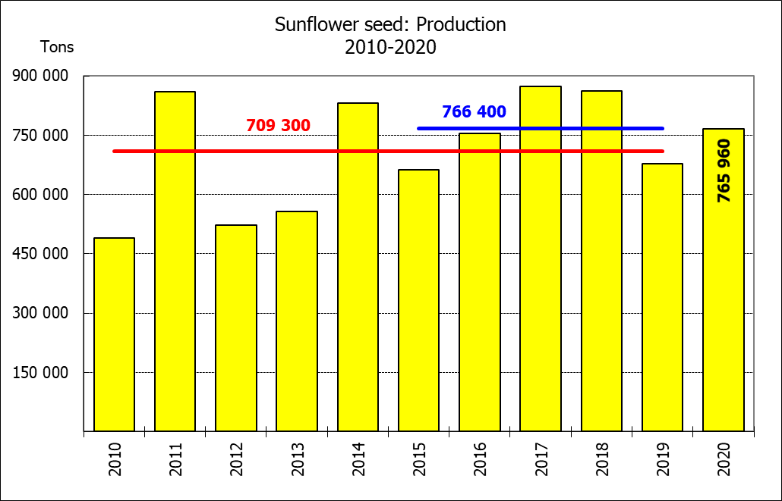

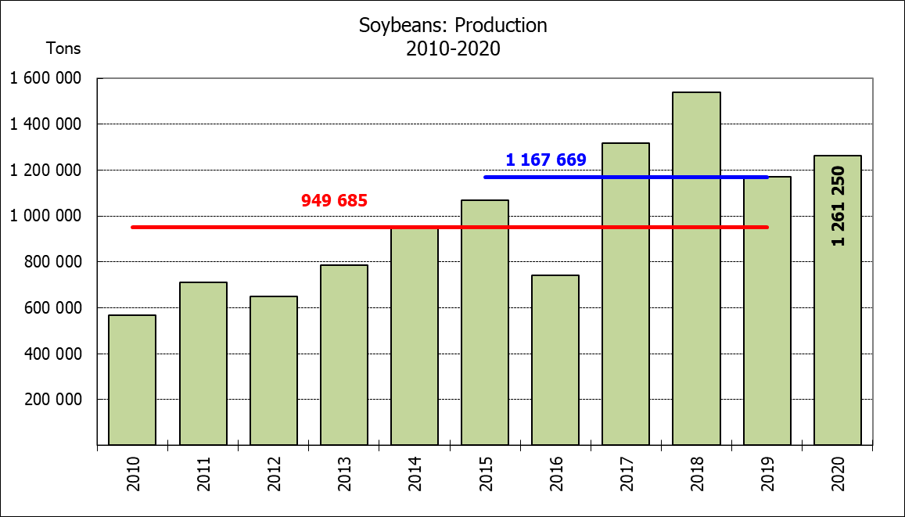
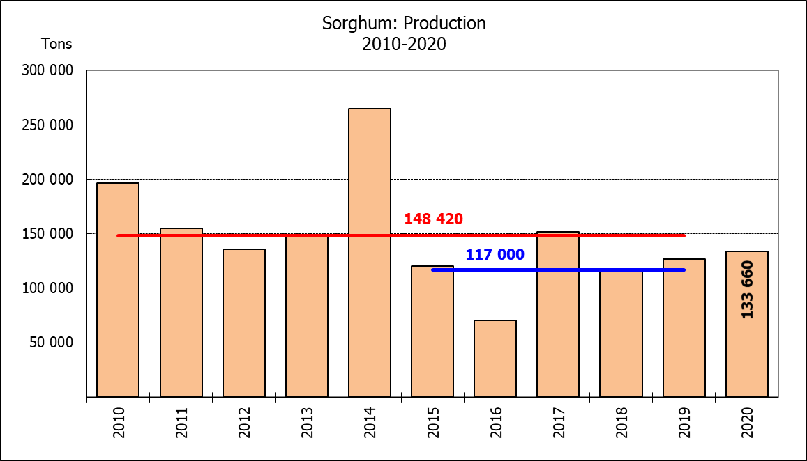

WHITE AND YELLOW MAIZE – AREA PLANTED AND FIFTH PRODUCTION FORECAST: 2020
WIT- EN GEELMIELIES – OPPERVLAKTE EN VYFDE PRODUKSIESKATTING: 2020

Provinsie/  Province | Area planted/  Oppervlakte beplant  2020 |  |  | 5th forecast/  5de skatting  2020 |  |  | Area planted/  Oppervlakte beplant  2019 |  |  | Final crop/  Finale oes  2019
Provinsie/  Province | White/  Wit  Ha | Yellow/  Geel  Ha | Total/  Totaal  Ha | White/  Wit  Tons | Yellow/  Geel  Tons | Total/  Totaal  Tons | White/  Wit  Ha | Yellow/  Geel  Ha | Total/  Totaal  Ha | White/  Wit  Tons | Yellow/  Geel  Tons | Total/  Totaal  Tons
Western Cape/Wes-Kaap | 400 | 3 400 | 3 800 | 3 600 | 30 600 | 34 200 | 400 | 3 400 | 3 800 | 3 600 | 30 600 | 34 200
Northern Cape/Noord-Kaap | 3 400 | 43 100 | 46 500 | 40 460 | 624 950 | 665 410 | 3 400 | 43 500 | 46 900 | 39 500 | 630 750 | 670 250
Free State/Vrystaat | 855 000 | 365 000 | 1 220 000 | 4 916 250 | 2 080 500 | 6 996 750 | 650 000 | 380 000 | 1 030 000 | 2 795 000 | 1 758 000 | 4 553 000
Eastern Cape/Oos-Kaap | 5 500 | 17 000 | 22 500 | 36 300 | 119 000 | 155 300 | 3 800 | 10 200 | 14 000 | 23 000 | 69 750 | 92 750
KwaZulu-Natal | 47 000 | 55 000 | 102 000 | 317 250 | 429 000 | 746 250 | 45 000 | 54 000 | 99 000 | 270 000 | 399 600 | 669 600
Mpumalanga | 160 000 | 353 000 | 513 000 | 944 000 | 2 223 900 | 3 167 900 | 145 000 | 338 000 | 483 000 | 797 500 | 1 977 300 | 2 774 800
Limpopo | 15 000 | 18 000 | 33 000 | 106 500 | 126 000 | 232 500 | 12 800 | 18 000 | 30 800 | 83 200 | 117 000 | 200 200
Gauteng | 55 000 | 50 000 | 105 000 | 335 500 | 310 000 | 645 500 | 48 000 | 60 000 | 108 000 | 259 200 | 348 000 | 607 200
North West/Noordwes | 475 000 | 90 000 | 565 000 | 2 375 000 | 495 000 | 2 870 000 | 390 000 | 95 000 | 485 000 | 1 274 000 | 399 000 | 1 673 000
Total/Totaal | 1 616 300 | 994 500 | 2 610 800 | 9 074 860 | 6 438 950 | 15 513 810 | 1 298 400 | 1 002 100 | 2 300 500 | 5 545 000 | 5 730 000 | 11 275 000

SUNFLOWER SEED – AREA PLANTED AND FIFTH PRODUCTION FORECAST: 2020
SONNEBLOMSAAD – OPPERVLAKTE EN VYFDE PRODUKSIESKATTING: 2020

Province/  Provinsie | Area planted/  Opp beplant  Ha | 5th forecast/  5de skatting  Tons | Area planted/  Opp beplant  Ha | Final crop/  Finale oes  Tons
Province/  Provinsie | 2020 | 2020 | 2019 | 2019
Western Cape/Wes-Kaap | - | - | - | -
Northern Cape/Noord-Kaap | 1 200 | 1 440 | 950 | 1 140
Free State/Vrystaat | 260 000 | 442 000 | 270 000 | 391 500
Eastern Cape/Oos-Kaap | 300 | 750 | 100 | 260
KwaZulu-Natal | - | - | - | -
Mpumalanga | 2 800 | 3 920 | 4 500 | 4 500
Limpopo | 65 000 | 61 750 | 61 000 | 61 000
Gauteng | 4 000 | 5 600 | 3 800 | 3 800
North West/Noordwes | 167 000 | 250 500 | 175 000 | 215 800
Total/Totaal | 500 300 | 765 960 | 515 350 | 678 000
SOYBEANS – AREA PLANTED AND FIFTH PRODUCTION FORECAST: 2020
SOJABONE – OPPERVLAKTE EN VYFDE PRODUKSIESKATTING: 2020

Province/  Provinsie | Area planted/  Opp beplant  Ha | 5th forecast/  5de skatting  Tons | Area planted/  Opp beplant  Ha | Final crop/  Finale oes  Tons
Province/  Provinsie | 2020 | 2020 | 2019 | 2019
Western Cape/Wes-Kaap | - | - | 100 | 10
Northern Cape/Noord-Kaap | 2 000 | 7 000 | 1 550 | 5 425
Free State/Vrystaat | 315 000 | 535 500 | 301 000 | 391 300
Eastern Cape/Oos-Kaap | 1 500 | 3 000 | 1 150 | 1 380
KwaZulu-Natal | 35 000 | 101 500 | 33 000 | 99 000
Mpumalanga | 260 000 | 416 000 | 310 000 | 511 500
Limpopo | 15 500 | 48 050 | 16 200 | 46 980
Gauteng | 36 000 | 70 200 | 31 500 | 66 150
North West/Noordwes | 40 000 | 80 000 | 36 000 | 48 600
Total/Totaal | 705 000 | 1 261 250 | 730 500 | 1 170 345

GROUNDNUTS – AREA PLANTED AND FIFTH PRODUCTION FORECAST: 2020
GRONDBONE – OPPERVLAKTE EN VYFDE PRODUKSIESKATTING: 2020

Province/  Provinsie | Area planted/  Opp beplant  Ha | 5th forecast/  5de skatting  Tons | Area planted/  Opp beplant  Ha | Final crop/  Finale oes  Tons
Province/  Provinsie | 2020 | 2020 | 2019 | 2019
Western Cape/Wes-Kaap | - | - | - | -
Northern Cape/Noord-Kaap | 1 200 | 2 700 | 1 200 | 2 520
Free State/Vrystaat | 11 000 | 17 050 | 8 000 | 9 775
Eastern Cape/Oos-Kaap | - | - | - | -
KwaZulu-Natal | - | - | - | -
Mpumalanga | - | - | - | -
Limpopo | 2 900 | 5 510 | 1 850 | 3 530
Gauteng | - | - | - | -
North West/Noordwes | 22 400 | 26 880 | 9 000 | 3 575
Total/Totaal | 37 500 | 52 140 | 20 050 | 19 400

SORGHUM – AREA PLANTED AND FIFTH PRODUCTION FORECAST: 2020
SORGHUM – OPPERVLAKTE EN VYFDE PRODUKSIESKATTING: 2020

Province/  Provinsie | Area planted/  Opp beplant  Ha | 5th forecast/  5de skatting  Tons | Area planted/  Opp beplant  Ha | Final crop/  Finale oes  Tons
Province/  Provinsie | 2020 | 2020 | 2019 | 2019
Western Cape/Wes-Kaap | - | - | - | -
Northern Cape/Noord-Kaap | - | - | - | -
Free State/Vrystaat | 8 000 | 30 400 | 8 000 | 23 600
Eastern Cape/Oos-Kaap | - | - | - | -
KwaZulu-Natal | 1 200 | 3 000 | 500 | 1 500
Mpumalanga | 8 500 | 42 500 | 7 500 | 36 000
Limpopo | 16 000 | 29 600 | 25 000 | 46 125
Gauteng | 300 | 960 | 1 000 | 3 200
North West/Noordwes | 8 500 | 27 200 | 8 500 | 16 575
Total/Totaal | 42 500 | 133 660 | 50 500 | 127 000

DRY BEANS – AREA PLANTED AND FIFTH PRODUCTION FORECAST: 2020
DROëBONE – OPPERVLAKTE EN VYFDE PRODUKSIESKATTING: 2020

Province/  Provinsie | Area planted/  Opp beplant  Ha | 5th forecast/  5de skatting  Tons | Area planted/  Opp beplant  Ha | Final crop/  Finale oes  Tons
Province/  Provinsie | 2020 | 2020 | 2019 | 2019
Western Cape/Wes-Kaap | 100 | 150 | 100 | 180
Northern Cape/Noord-Kaap | 350 | 700 | 1 000 | 1 400
Free State/Vrystaat | 24 000 | 30 000 | 27 000 | 28 350
Eastern Cape/Oos-Kaap | 200 | 300 | 400 | 720
KwaZulu-Natal | 2 900 | 3 480 | 3 500 | 4 025
Mpumalanga | 6 600 | 8 250 | 7 500 | 6 750
Limpopo | 8 400 | 16 800 | 7 800 | 12 480
Gauteng | 600 | 780 | 1 500 | 1 950
North West/Noordwes | 7 000 | 8 400 | 10 500 | 10 500
Total/Totaal | 50 150 | 68 860 | 59 300 | 66 355

CONFIDENTIALITY ISSUES that CEC members are committed to adhere to on the day of the meeting
- Personal items such as laptops, handbags, cell phones, etc. are not allowed in the venue during the meeting
- No member is allowed to leave the meeting before 12:00 in order to prevent disclosure of the information
- The embargo time for the release of crop estimates information is 14:30
- No member is allowed to discuss crop estimates information with anyone other than a member of the Committee before the embargo time
- Only the Chairperson, or a member appointed by the Chairperson, may release the figures to the media
- Members must regard the detail of any information that was collected for and/or discussed during the meeting, as confidential
- Individual information received for crop estimate purposes is treated strictly confidential, and is not divulged for any other purposes

AREA ESTIMATE AND FIFTH PRODUCTION FORECAST OF SUMMER CROPS (2020 PRODUCTION SEASON)/
OPPERVLAKTE- EN VYFDE PRODUKSIESKATTING VIR SOMERGEWASSE (2020 PRODUKSIE-SEISOEN)
25 JUNE/JUNIE 2020

Summer field crops – 2020  Commercial maize: The size of the expected commercial maize crop has been set at 15,514 mill. tons, which is 0,48% or 75 600 tons less than the previous forecast of 15,589 mill. tons. The area estimate for maize is 2,611 mill. ha, while the expected yield is 5,94 t/ha.  The estimated maize crop is 38% bigger than the 2019 crop. The three main maize producing areas, namely the Free State, Mpumalanga and North West provinces are expected to produce 84% of the 2020 crop.  The area estimate for white maize is 1,616 mill. ha & for yellow maize the area estimate is 994 500 ha.  The production forecast of white maize remained unchanged at 9,075 mill. tons, with an expected yield of 5,61 t/ha. In the case of yellow maize the production forecast is 6,439 mill. tons, which is 1,16% or 75 600 tons less than the 6,514 mill. tons of the previous forecast. The yield for yellow maize is 6,47 t/ha.  Sunflower seed: The production forecast for sunflower seed is 765 960 tons, unchanged from the previous forecast. The area estimate for sunflower seed is 500 300 ha, while the expected yield is 1,53 t/ha.  Other crops: The production forecast for soybeans has decreased by 2,29% or 29 500 tons, from 1,291 mill. tons to 1,261 mill. tons. The estimated area planted to soybeans is 705 000 ha and the expected yield is 1,79 t/ha.  The expected groundnut crop is 52 140 tons – a decrease of 16,54% or 10 330 tons. The area estimate is 37 500 ha, with an expected yield of 1,39 t/ha.  The production forecast for sorghum is 133 660 tons, which is 1,49% or 2 025 tons less than the 135 685 tons of the previous forecast. The area estimate for sorghum is 42 500 ha and the expected yield is 3,14 t/ha.  In the case of dry beans, the production forecast is 68 860, which is 3,08% or 2 190 tons less than the previous forecast. The area estimate of dry beans is 50 150 ha, with an expected yield of 1,37 t/ha.  Please note that the sixth production forecast for summer field crops for 2020 will be released on 29 July 2020. |  | Somergewasse – 2020  Kommersiële mielies: Die grootte van die verwagte kommersiële mielie-oes is op 15,514 milj. ton gestel, wat 0,48% of 75 600 ton minder is as die vorige skatting van 15,589 milj. ton. Die skatting van die oppervlakte onder mielies is 2,611 milj. ha, terwyl die verwagte opbrengs 5,94 t/ha is.  Die geskatte mielie-oes is 38% groter as die 2019-oes. Die drie belangrikste mielieproduserende gebiede, nl. die Vrystaat, Mpumalanga en Noordwes provinsies, gaan na verwagting 84% van die 2020-oes produseer.  Die oppervlak onder witmielies is 1,616 milj. ha en vir geelmielies is die oppervlak 994 500 ha.  Die produksieskatting van witmielies is onveranderd gelaat op 9,075 milj. ton, met ’n verwagte opbrengs van 5,61 t/ha. In die geval van geelmielies is die produksieskatting 6,439 milj. ton, wat 1,16% of 75 600 ton minder is as die 6,514 milj. ton van die vorige skatting. Die opbrengs van geelmielies is 6,47 t/ha.  Sonneblomsaad: Die produksieskatting vir sonneblomsaad is 765 960 ton, onveranderd teenoor die vorige skatting. Die oppervlakteskatting vir sonneblomsaad is 500 300 ha, terwyl die verwagte opbrengs 1,53 t/ha is.  Ander gewasse: Die produksieskatting van sojabone het met 2,29% of 29 500 ton afgeneem, van 1,291 milj. ton tot 1,261 milj. ton Die geskatte oppervlakte beplant van sojabone is 705 000 ha en die verwagte opbrengs is 1,79 t/ha.  Die verwagte grondbone-oes is 52 140 ton – ’n afname van 16,54% of 10 330 ton. Die oppervlakteskatting is 37 500 ha, terwyl the verwagte opbrengs 1,39 t/ha is.  Die produksieskatting van sorghum is 133 660 ton, wat 1,49% of 2 025 ton minder is as die 135 685 ton van die vorige skatting. Die oppervlakteskatting vir sorghum is 42 500 ha, en die verwagte opbrengs is 3,14 t/ha.  In die geval van droëbone is die produksieskatting 68 860 ton wat 3,08% of 2 190 ton minder is as die vorige skatting. Die oppervlakte beplant met droëbone is 50 150 ha, en die verwagte opbrengs is 1,37 t/ha.  Neem asseblief kennis dat die sesde produksieskatting vir somergewasse vir 2020, op 29 Julie 2020 vrygestel sal word.
Information is available on the internet at http://www.dalrrd.gov.za/statistics and economic reports or http://www.sagis.org.za, as from 14:30 on the date of the relevant meeting of the Crop Estimates Committee. |  | Inligting is beskikbaar op die internet by http://www.dalrrd.gov.za/statistics and economic reports of by http://www.sagis.org.za, vanaf 14:30 op die dag van die toepaslike vergadering van die Oesskattingskomitee.

The preliminary non-commercial agricultural sectors’ production estimate for maize for 2020 is hereby released. /
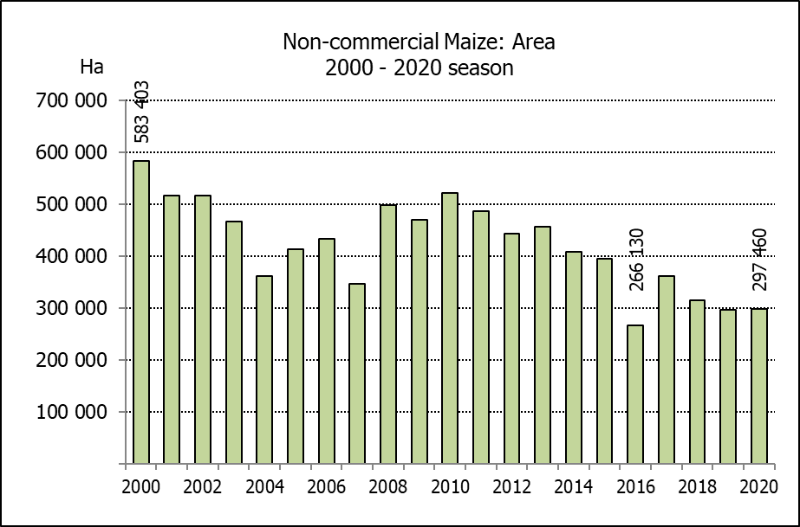
Hiermee word die voorlopige nie-kommersiële landbou-sektor se produksieskatting vir mielies vir 2020 vrygestel.

NON-COMMERCIAL MAIZE – PRELIMINARY AREA PLANTED AND PRODUCTION ESTIMATE: 2020
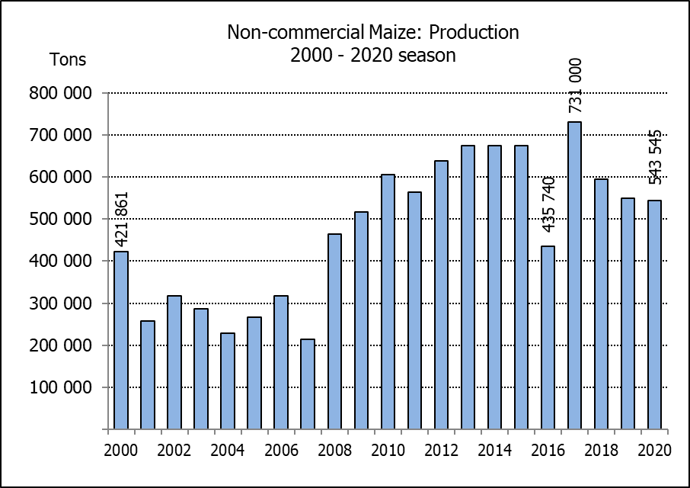
NIE-KOMMERSIëLE MIELIES – VOORLOPIGE OPPERVLAKTE- EN PRODUKSIESKATTING: 2020
CROP/GEWAS | Area planted/  Opp beplant  2020 | Production/  Produksie  2020 | Area planted/  Opp beplant  2019 | Final crop/  Finale oes  2019 | Change/  Verandering
CROP/GEWAS | Ha | Tons | Ha | Tons | %
CROP/GEWAS | (A) | (B) | (C) | (D) | (B) ÷ (D)
Non-commercial agriculture/Nie-kommersiële landbou:
White maize/Witmielies | 221 945 | 375 295 | 221 300 | 379 460 | -1,10
Yellow maize/Geelmielies | 75 515 | 168 250 | 74 700 | 169 720 | -0,87
Maize/Mielies | 297 460 | 543 545 | 296 000 | 549 180 | -1,03
The preliminary area planted to maize in the non-commercial agricultural sector is estimated at 297 460 ha, which represents a slight increase of 0,49%, compared to the 296 000 ha of the previous season. The expected maize crop for this sector is 543 545 tons, which is 1,03% less than the 549 180 tons of last season. It is important to note that about 40% of the maize produced in the non-commercial sector, is planted in the Eastern Cape, followed by KwaZulu-Natal with 27%.
Die voorlopige oppervlakte beplant met mielies in die nie-kommersiële landbou-sektor word geskat op 297 460 ha, wat ’n effense toename van 0,49 % verteenwoordig in vergelyking met die 296 000 ha van die vorige seisoen. Die verwagte mielie-oes van dié sektor is 543 545 ton, wat 1,03% minder is as die 549 180 ton van die vorige seisoen. Dit is belangrik om daarop te let dat ongeveer 40% van die mielies wat geproduseer word in die nie-kommersiële sektor, in die Oos-Kaap geplant word, gevolg deur KwaZulu-Natal met 27%.

