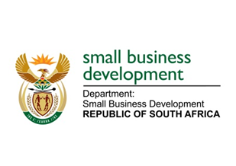

NATIONAL ASSEMBLY
QUESTION FOR WRITTEN REPLY
DUE TO PARLIAMENT: FRIDAY, 11 SEPTEMBER 2020

1953. Ms R N Komane (EFF) to ask the Minister of Small Business Development:
What total (a) amount has been disbursed by the Small Enterprise Finance Agency and (b) number of businesses have been supported through the Covid-19 Emergency Relief Funds since the declaration of a national state of disaster? NW2249E

REPLY:

Programme | a) Amount Disbursed | b) Number of SMMEs/Spazas
SMMEs Debt Relief Fund | R306.7million | 1 159
Spaza Shops Support Programme | R16.2 million | 4 626

